A Study into the effectiveness of the Anti-Bullying Procedures on Traveller and Roma pupils’ experiences in the school system

February 2022

Author: Dr Maeve Dupont

Research team: Kathleen Lawrence, Lena Lawrence, and Bianca Paun

Acknowledgements:
I wish to express my gratitude to the research team (Kathleen, Lena and Bianca) for their dedication to the project during a global pandemic.
I also wish to thank the pupils, parents and anti-bullying co-ordinators who took part in the study and to ABC colleagues Derek Laffan, Prof. James O’Higgins Norman and Geraldine Kiernan for their help throughout the process of creating this report.

This report is published by DCU Anti-Bullying Centre (ABC)

Preface

DCU Anti-Bullying Centre (ABC) is a University designated research centre located in DCU’s Institute of Education. The Centre is known globally for its research excellence in bullying and online safety. The Centre is home to a team of scholars with a global reputation as leaders in their field. The aim of ABC is to contribute to solving the real-world problems of bullying and online safety through collaboration with an extensive international community of academic and industry partnerships. The extent of the Centre’s resources and the collaboration between disciplines drive quality education, understanding and innovation in this field.

The Centre hosts the UNESCO Chair on Tackling Bullying in Schools and Cyberspace, and is the home of the International Journal of Bullying Prevention. The objectives of the Centre are aligned to support the UN’s overarching goal to “ensure inclusive and equitable quality education” and “promote lifelong learning opportunities for all” by 2030 (SDG4) and support the implementation of the Government of Ireland’s Action Plan on Bullying (2013), Action Plan for Online Safety (2018-2019), the Wellbeing Policy Statement and Framework for Practice (2018-2023), and the Workplace Relations Commission/Health and Safety Authority’s Code of Practice for Employers and Employees on the Prevention of and Resolution of Bullying at Work (2021).

Table of Contents
1. Introduction 3
2. Traveller and Roma pupils’ experiences of bullying in school 5
3. Traveller and Roma pupils’ experiences of discrimination 23
4. Traveller and Roma parents’ perspectives on their children’s experience of bullying in school 29
5. Anti-bullying co-ordinators’/teachers perspectives on actions to prevent and counteract bullying towards Traveller and Roma pupils 36
6. Summary and Conclusion 45
7. Implications, limitations and recommendations 48
References 52

Figures

Figure 2.1: Participants’ attitudes towards school 10

Figure 2.2: Participants’ reports of the number of good friends

in their class 11

Figure 2.3: Participants’ reported experience of bullying in the

year prior to the study 12

Figure 2.4: Participants’ reports of the duration of bullying that

they experienced 13

Figure 2.5: Type of bullying experienced by participants 13

Figure 2.6: Peer awareness of participants’ ethnic group

membership 14

Figure 2.7: Locations where participants were bullied 15

Figure 2.8: Participants’ reported fear of being bullied 16

Figure 2.9: Participants’ perceptions of whether the proportion
of fellow ethnic group members in their school
influenced their risk of being bullied 16

Figure 2.10: Participants’ reports of persons they told about

the bullying 18

Figure 2.11: Participants’ reasons for not reporting bullying to

a teacher 19

Figure 2.12: Participants’ description of actions taken by the
teacher following a report of bullying 20

Figure 2.13: Participants’ happiness with the teacher response

to bullying 20

Figure 2.14: Participants’ perceptions of teacher effectiveness
with regard to putting a stop to bullying 21

Figure 2.15: Participants’ perceptions of how often teachers try
to put a stop to bullying in general 22

Figure 2.16: Participants’ perceptions of how often other students
try to put stop to bullying in general 23

Figure 2.17: Participants’ reports of what their school does to
help pupils to recognise and deal with bullying 24

Figure 3.1: Participants’ perceptions of how often other students
said they don’t belong in Ireland 26

Figure 3.2: Participants’ perceptions of how often other students
didn’t want to play with them because of their ethnic
group membership 27

Figure 3.3: Participants’ perceptions of how often they were left out
by a student because of their ethnic group membership. 27

Figure 3.4: Participants’ perceptions of how often they were called
names by other students because of their ethnic
group membership 28

Figure 3.5: Participants’ perceptions of how often they were spat on,
pushed or hit by other students because of their
ethnic group membership 28

Figure 3.6: Participants’ perceptions of how often other students
left them out because of their membership of the Traveller/Roma community 29

Figure 3.7: Participants’ perceptions of how often other students
are called names or teased because of their
membership of the Traveller/Roma community 29

Figure 3.8: Participants’ perceptions of how often other students
are spat on, pushed or hit because of their
membership of the Traveller/Roma community 30

Figure 3.9: Participants’ perceptions of how often a teacher thought
they couldn’t do something because of their
membership of the Traveller/Roma community 30

Figure 3.10: Participants’ perceptions of how often they were left out
by a teacher because of their membership of the Traveller/Roma community 31

Figure 4.1: Parents’ perceptions of how much their child likes school 33

Figure 4.2: Parents’ reports of how often their child was bullied at
school in the year prior to the study 33

Figure 4.3: Parents’ happiness with the school response to reports
that their child was bullied 35

Figure 4.4: Parents’ perceptions regarding how helpful the school
was at putting a stop to the bullying (following a
bullying report) 36

Figure 4.5: Parents’ reports of school actions to support parents to recognise and deal with bullying 38

Figure 5.1: Primary role of participants occupying the role of
anti-bullying co-ordinator 40

Figure 5.2: Approximate proportion of pupil population that are
members of the Traveller/Roma community 41

Figure 5.3: Participants’ reports regarding whether or not their
school’s anti-bullying policy refers specifically to
bullying of children and young people relating to
their membership of the Traveller/Roma community 41

Figure 5.4: Participants’ reports regarding whether or not their
school records incidents of identity based bullying
specifically related to Traveller/Roma group membership 42

Figure 5.5: Participants’ reports regarding whether their school has
any evidence related to the prevalence of identity based
bullying towards Traveller/Roma pupils 43

Figure 5.6: Participants’ reports regarding the number of incidents of
identity based bullying towards Traveller/Roma in the 12 months prior to the study 43

Figure 5.7: Participants’ reports regarding actions to counteract
bullying 45

Figure 5.8: Participants’ reports regarding strategies to communicate
the school’s anti-bullying policy to the school community 46

1. Introduction

Background and context

The National Traveller and Roma Inclusion Strategy (Department of Justice and Equality, 2017) is a cross-departmental initiative to improve the lives of two of the most socially excluded and marginalised communities in Ireland. One of the key objectives of the Strategy is that access, participation and outcomes for Travellers and Roma in education should be improved to achieve outcomes that are equal to those for the majority population.

Focus and purpose of current study

School bullying undermines the quality of education and can have short and long-term effects on pupils’ physical and mental well-being, their engagement with school, and their capacity to pursue ambitions and interests. Thus, following concerns of bullying towards Traveller and Roma pupils at school, the Department of Education commissioned research on the effectiveness of their anti-bullying procedures for primary and post-primary schools (Department of Education and Skills, 2013) on Traveller and Roma pupils’ experiences in the school system.

The following report has been developed by researchers at DCU’s National Anti-Bullying Research and Resource Centre and this project responds directly to the Department of Education’s request. The research was designed in consultation with representatives of the Traveller and Roma communities and members of these communities were involved as members of the research team.

Methodology

Two Traveller and one Roma researcher interviewed Traveller and Roma pupils and parents in five counties across the Republic of Ireland. Pupil and parent participants were recruited via local contacts in these communities.

Traveller and Roma pupils were asked questions from an adapted version of the Olweus pupil bullying questionnaire (Olweus, 2006). Additional questions (informed in consultation with Traveller and Roma organisations represented on the National Traveller and Roma Inclusion Strategy (NTRIS) Education sub-group) were also included. Pupils were also asked to complete a perceived discrimination scale that investigated the degree to which they felt that they, or members of their community, had been discriminated against by peers and teachers at school.

The parent survey (designed by researchers at DCU’s National Anti-Bullying Research and Resource Centre) asked about their child’s experiences of bullying along with their perceptions of the school’s
handling of bullying and what their child’s school does to help parents recognise and deal with bullying. The survey concluded by seeking parents’ views on how their child’s experience of bullying affected their
participation in school.

The project also included teachers (anti-bullying coordinators) in primary and post-primary schools who were invited to complete an online survey. Teachers were asked about: their anti-bullying policies (including the content and communication of same); recording incidents of ethnicity based bullying; and actions to counteract and prevent ethnicity based bullying towards Traveller and Roma pupils.

The findings from pupils are presented first.

2. Traveller and Roma pupils’ experiences of bullying in school

Description of pupil bullying survey
An adapted version of the Olweus pupil bullying questionnaire (Olweus, 2006) was used to investigate bullying towards Traveller and Roma pupils. Additional questions (informed in consultation with Traveller and Roma organisations represented on the National Traveller and Roma Inclusion Strategy (NTRIS) Education sub-group) were also included. The survey was mainly quantitative in nature, however one out of the 37 questions allowed for a more open-ended qualitative response. Researchers also added participants’ comments where relevant to assist interpretation of findings. In some cases, the survey was read to participants and the researcher recorded their responses, other respondents opted to complete the survey independently.
The survey included questions about: the participants’ gender and ethnicity; how much they like school; and the number of good friends they have in their class. They were also asked about their experiences of bullying in the previous year. Information was sought about the frequency, nature and duration of bullying. They were also asked about the perpetrator(s) of bullying including; their gender number and ethnicity; whether they were in a different class or grade; and whether or not they had been bullied by teachers. Following concerns that Traveller and Roma pupils do not report bullying, they were asked a series of questions about reporting bullying and possible reasons they might not have reported incidents of bullying. Their perceptions of teachers’ and peers’ handling of bullying were also sought along with a description of what their school does to help pupils recognise and deal with bullying. In order to assist with the interpretation of findings, pupils were asked whether their peers were aware of their ethnic group membership and whether the proportion of fellow ethnic group members in their school influences their perceived risk of being bullied. The survey concluded by seeking pupils’ views on how their experience of bullying affected their participation in school.
The pupil findings are presented below. Where relevant the findings from Traveller and Roma pupils are presented separately.

Pupil participant profile
Forty-two Traveller pupils (22 female and 20 male) and 29 Roma pupils (19 female and 10 male) took part in the study. Pupils ranged in age from 5 to 18 with a mean age of 12.6 and a median age of 12. Two participants did not provide their age. Thirty-four participants were in primary school and 35 attended post-primary school. Two 17 year-old male respondents (one Traveller and one Roma) added that they had left school. The Traveller pupil was attending Youth Reach and described it as 100 times better than school. Similarly, the Roma pupil moved to a learning support centre and was enjoying it much better.

Pupils’ attitudes towards school
Participants were asked whether they liked school. Most respondents expressed a favourable attitude towards school. 31% (n=13) of Travellers and 82.8% (n=24) of Roma pupils indicated that they like school with a further 28.6% (n=12) of Travellers and 6.9% (n=2) of Roma stating that they like school very much. Some pupils were less enthusiastic with 21.4% (n=9) of Travellers and 10.3% (n=3) of Roma pupils reporting that they neither like nor dislike school. There was evidence of negative experiences of school, particularly among Traveller participants. 14.3% (n=6) of Travellers commented that they dislike school with a further 4.8% (n=2) saying they dislike school very much.
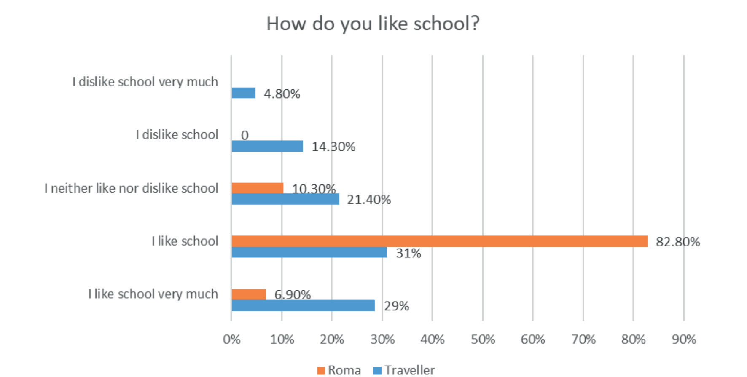
Figure 2.1: Participants’ attitudes towards school (n=71)

Pupils’ friends in school
When asked how many good friends they have in their class, almost all participants had a few (or more) good friends. 45.2% (n=19) of Travellers and 34.5% (n=10) of Roma, stated that they have 6 or more good friends in their class. 33.3% (n=14) of Travellers and 20.7% (n=6) of Roma pupils reported having 4 or 5 good friends. It is worth noting that two Traveller respondents commented that all their friends were Travellers. 16.7% (n=7) of Traveller and 37.9% (n=11) of Roma pupils estimated that they have 2 or 3 good friends in their class. 2.4% (n=1) of Traveller and 3.4% (n=1) of Roma pupils indicated that they have just one good friend in their class. Regrettably, 2.4% (n=1) of Traveller pupils said they had no good friends in their class.
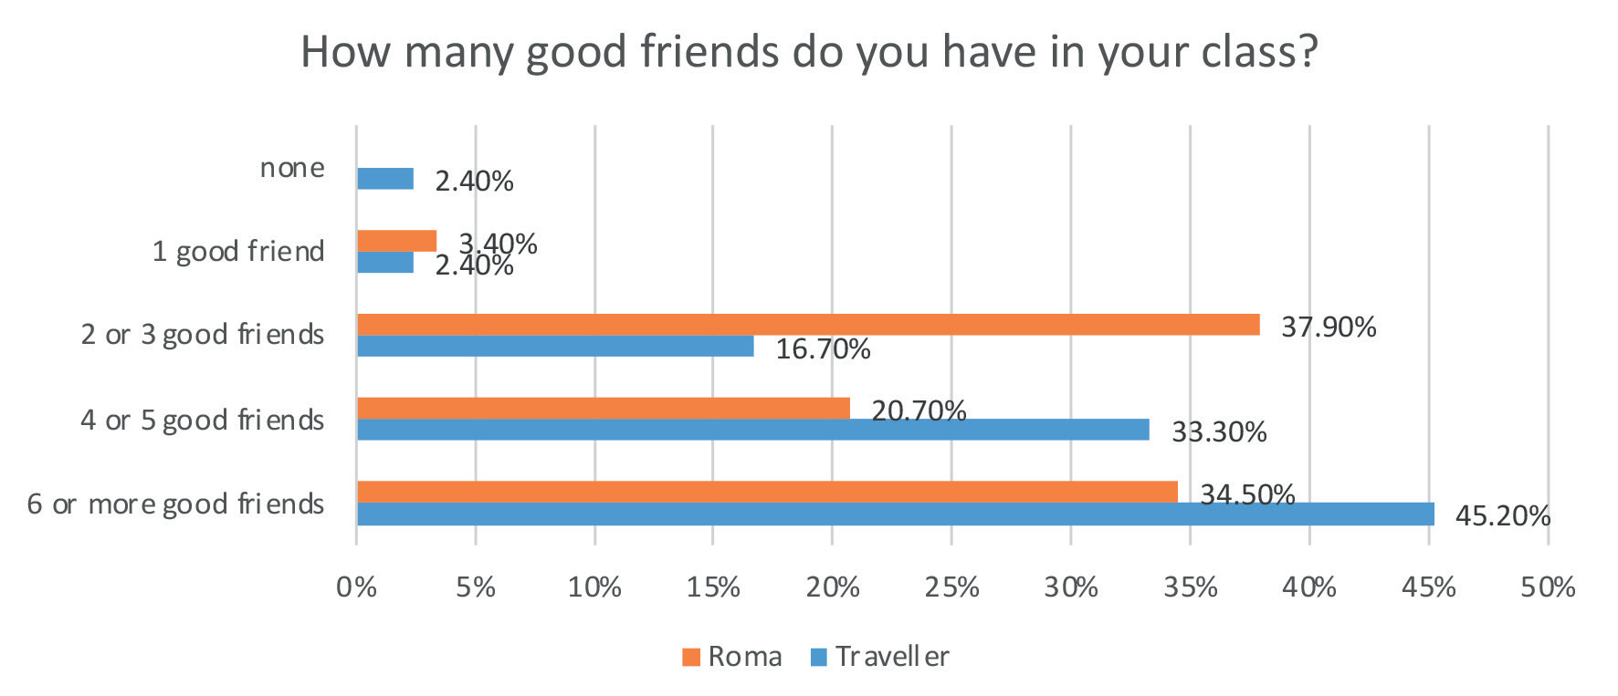
Figure 2.2: Participants’ attitudes towards school (n=71)

Pupils’ experience of bullying
Pupils were given a definition of bullying and asked: how often they had been bullied in the past year; how long the bullying lasted; and in what way they were bullied. Bullying was defined as when another student or several other students say mean and hurtful things or make fun of you or call you mean and hurtful names; completely ignore or exclude you from their group of friends or leave you out of things on purpose; hit, kick, push, shove around or lock you inside a room; tell lies or spread false rumours about you or send mean notes and try to make other students dislike you and other hurtful things like that. It was emphasised that when we talk about bullying these things happen repeatedly and it is difficult for the student being bullied to defend him or herself.

Frequency of bullying

Most of the pupils surveyed indicated that they had not been bullied at school in the past year. Specifically, 81% (n=34) of Traveller and 89.7% (n=26) of Roma participants reported that they had not been bullied at school in the past year1. 4.8% (n=2) of Traveller and 6.9% (n=2) of Roma pupils said that it happened only once or twice2 and 2.4% (n=1) of Traveller and 3.4% (n=1) of Roma pupils said that they were bullied two or three times a month. 2.4% (n=1) of Travellers pupil indicated that they were bullied about once a week and 9.5% (n=4) of Traveller pupils stated that they were bullied several times a week.
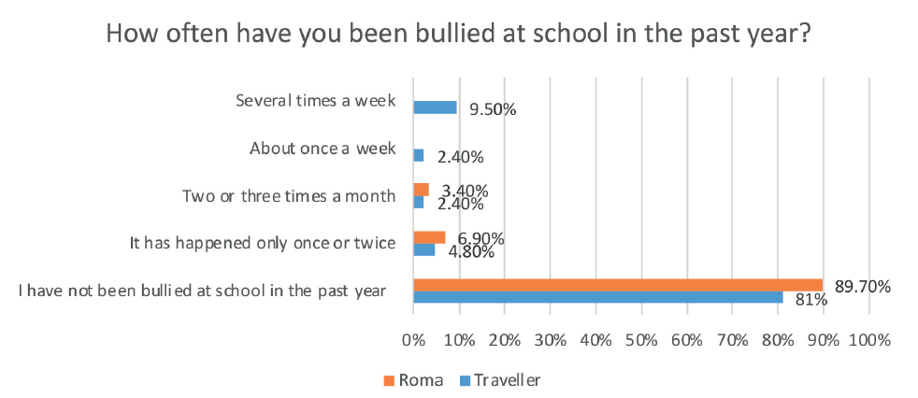
Figure 2.3: Participants’ reported experience of bullying in the year prior to the study (n=71)

Duration of bullying

For those who were bullied, the most commonly reported duration of bullying was one or two weeks. However, for three Traveller pupils, the bullying persisted for greater than six months and all of these pupils maintained that they were still being bullied. One pupil did not specify how long the bullying lasted but commented “teachers, still happening”. Another respondent who earlier affirmed that they had been bullied in the previous year skipped the question. In addition, the Traveller pupil who
experienced multiple types of bullying indicated (in response to how long the bullying lasted) that she had not been bullied in the past year. Perhaps she was confused by the time frame.
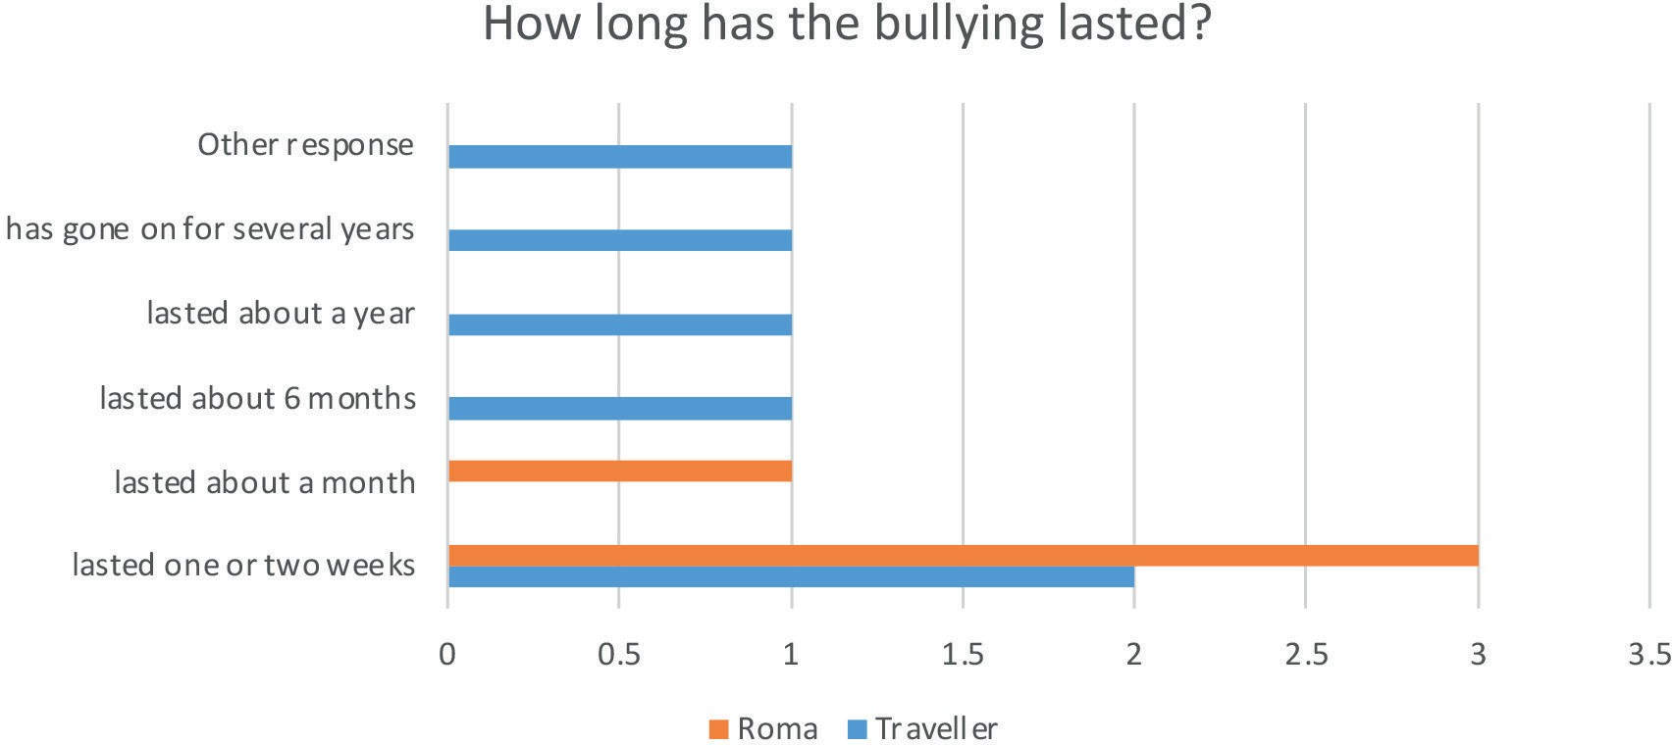
Figure 2.4: Participants’ reports of the duration of bullying that they experienced (n=10)

Type of bullying

All participants were asked whether they had experienced different types of bullying. Twelve participants reported experiencing various types of bullying and all twelve were subjected to more than one type of bullying by their peers. The most common types of bullying reported by participants
involved: name calling (including racist name calling); being excluded and ignored; and other students spreading rumours and trying to make others dislike them.

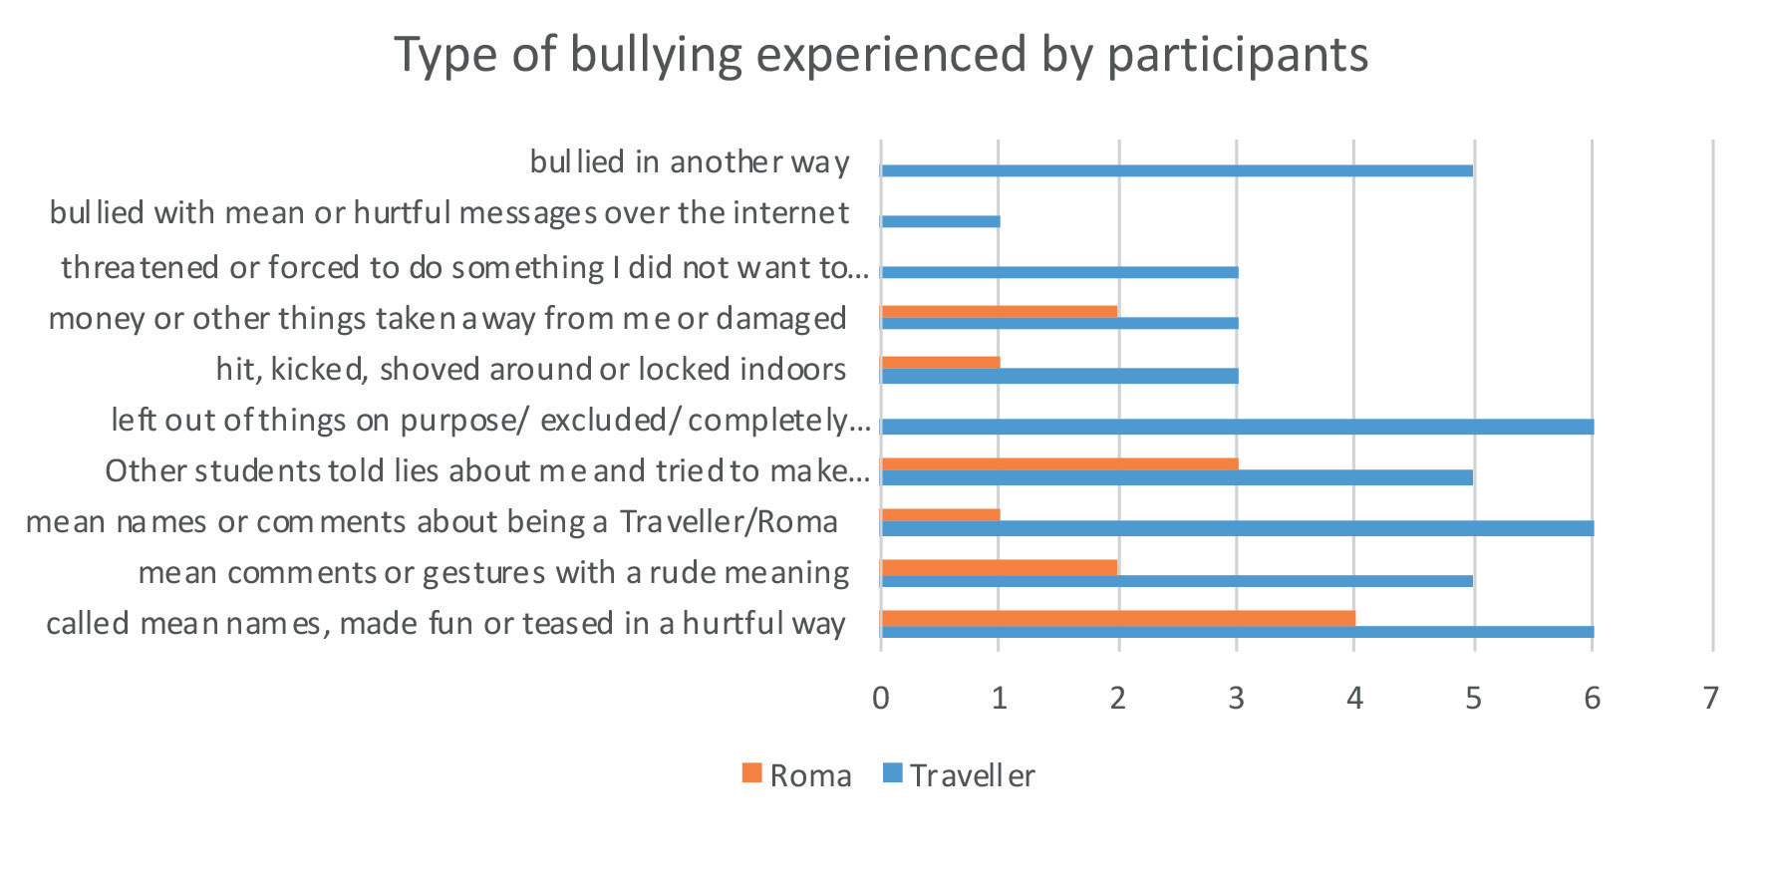
Figure 2.5: Type of bullying experienced by participants (n=12)
*All 12 participants experienced more than one type of bullying

Peer awareness of participants’ ethnic group membership

In order to assist with the interpretation of young people’s reports of their experiences with ethnicity-based bullying (and because some Travellers conceal their ethnic identity due to fear of harassment) they were asked whether children at their school know their ethnic group membership. Most pupil respondents (84.6% (n=33) Traveller and 69% (n=20) Roma) indicated that children at their school are aware of their ethnic group membership. Also, all of the pupils who affirmed that they had been bullied in the previous year stated that their peers were aware of their ethnic group membership.

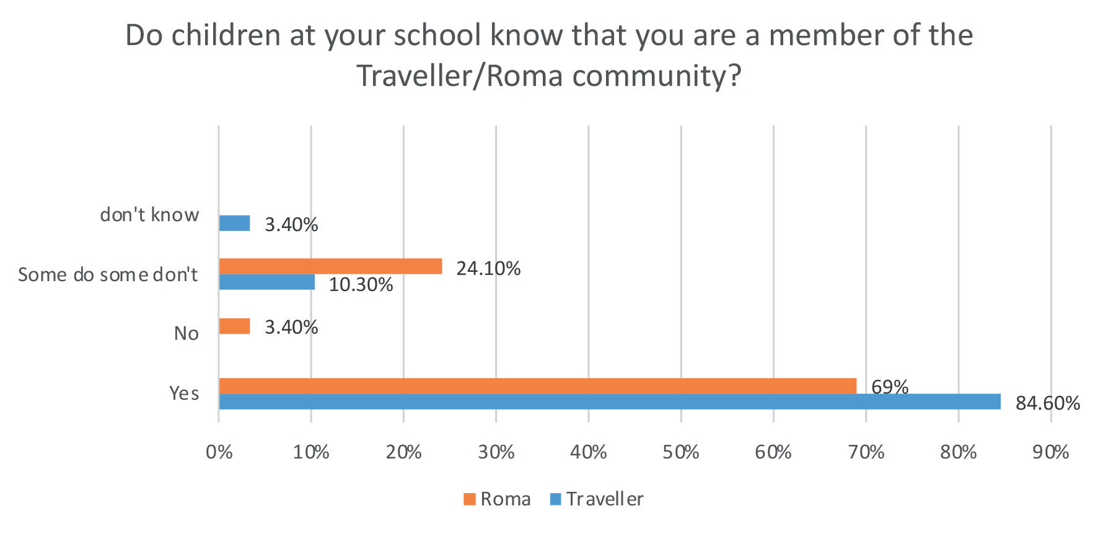
Figure 2.6: Peer awareness of participants’ ethnic group membership (n=68)

With regard to other types of bullying, there were comments from five Traveller pupils and one Roma pupil describing incidents of bullying that were perpetrated variously by teachers, a parent, a peer, and a neighbour. The comments about teacher bullying are included under the section ‘bullying by teachers.

One teenage Traveller pupil described being bullied by a parent and how the parent of a student called me names and hit me. The guards know about it and did nothing about it. I am afraid to walk the streets over it.

There was also evidence of harassment. One Traveller primary school pupil described how “a girl wrote under a picture about dirty gypsies and I was called a gypsy too.” In addition, one Roma primary school pupil recounted how her neighbours said “go back to your country”.

Overall, among the pupils surveyed, it seems that name calling and relational types of bullying are more frequently experienced than physical bullying. There are also some types of bullying that were only encountered by Traveller participants such as: being ignored and excluded; being threatened; being bullied by parents and teachers; and cyberbullying.

Pupils’ reports of where the bullying took place

When asked where the bullying took place, there were responses from 13 pupils (including an additional pupil who indicated that they were bullied by a teacher). Nine participants, who had been bullied, experienced bullying in more than one location. Similar to previous studies on bullying with other populations, the most common areas where pupils experienced bullying were in places with typically lower levels of adult supervision. For instance, 11.3% (n=5 Traveller pupils and n=3 Roma pupils) reported that they had been bullied on the playground/athletic field during break time and 8.5% (n=5 Travellers and n=1 Roma) of pupils indicated that they were bullied in class when the teacher was not in the room. However, it is concerning that 8.5% (n=6 Travellers) reported that they were bullied in class when the teacher was in the room. Analysis of their responses revealed that all of the 6 pupils were Travellers and 5 of them were being bullied by teachers.

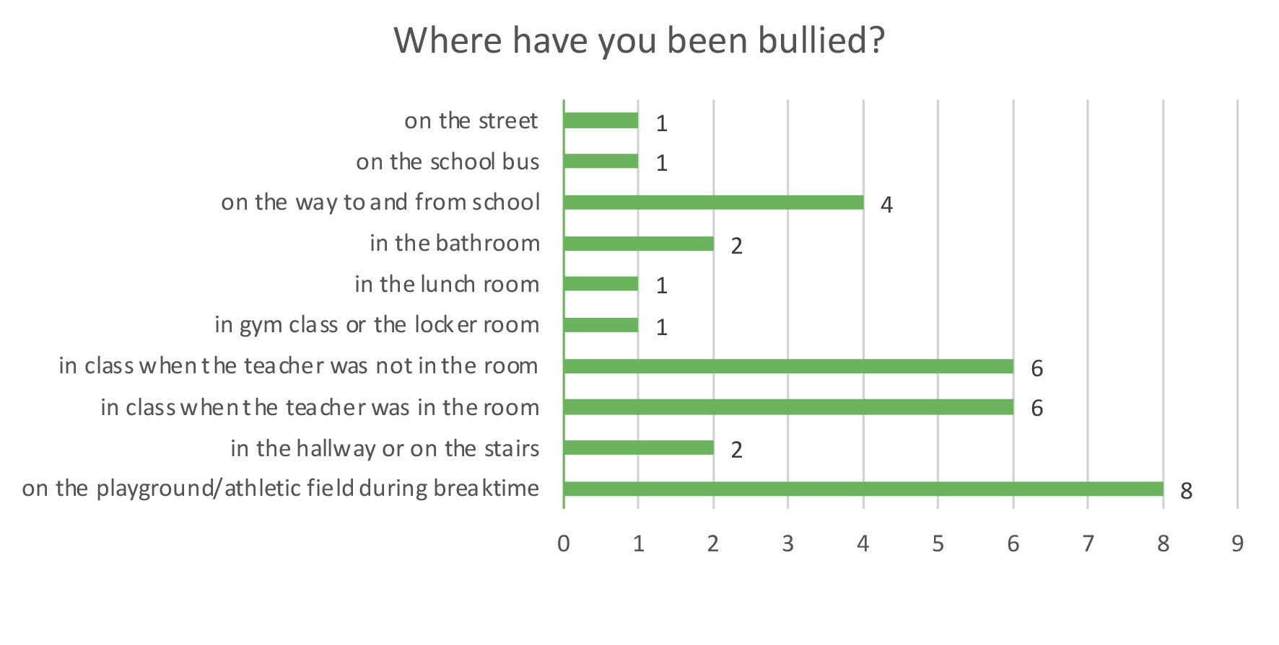
Figure 2.7: Locations where participants were bullied, n= (13) *participants reported multiple locations

Pupils’ feelings about bullying (fear and perceived risk)

All participants were asked about their fear of being bullied. Most of the pupils (65.8% (n=25) Traveller and 93.1% (n=27) Roma) reported that they were never afraid of being bullied. However, a proportion of Traveller pupils were more frequently afraid of being bullied with 13.2% (n=5) of Travellers saying they were sometimes afraid and 2.6% (n=1) indicating that they were afraid of being bullied all the time. It seems that (for the most part) their fears were based on experience as four out of these six Traveller respondents had experienced bullying at school.

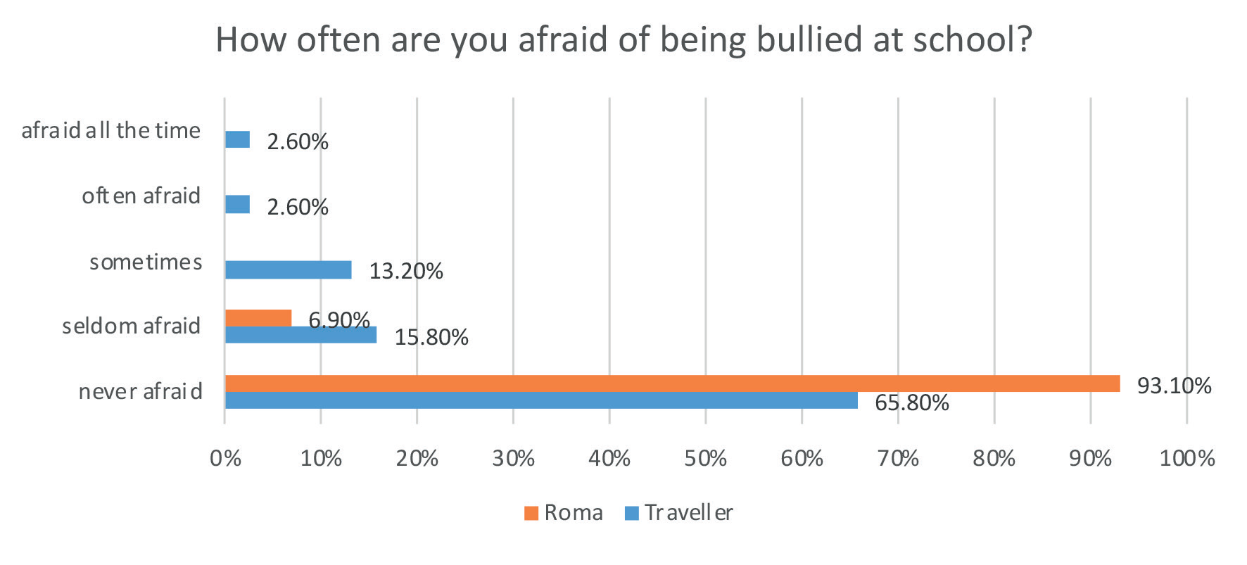
Figure 2.8: Participants’ reported fear of being bullied (n=67)

The study also investigated whether the proportion of fellow ethnic group members in their school influenced participants’ perceptions of their risk of being bullied. Pupils were asked to indicate their level of agreement with the statement ‘When there are a lot of Travellers/Roma in my class/school, I feel less likely to be bullied’. Most Roma pupils agreed with the statement with 37.9% (n= 11) strongly agreeing and 48.3% (n=14) agreeing. By contrast only 10.3% (n=4) Travellers strongly agreed, and 12.8% (n=5) Travellers agreed with the statement. One of the Travellers noted that it was a security. 10.3% (n=3) of Roma pupils and 38.5% (n=15) Travellers were unsure about how the ethnic composition of the school influenced their risk of being bullied. 23.1% (n=9) Travellers and 3.4% (n=1) Roma disagreed, and 10.3% (n=4) Travellers strongly disagreed with the idea that a greater proportion of fellow ethnic group members reduced their likelihood of being bullied. Two Travellers elaborated by stating that it doesn’t make a difference.

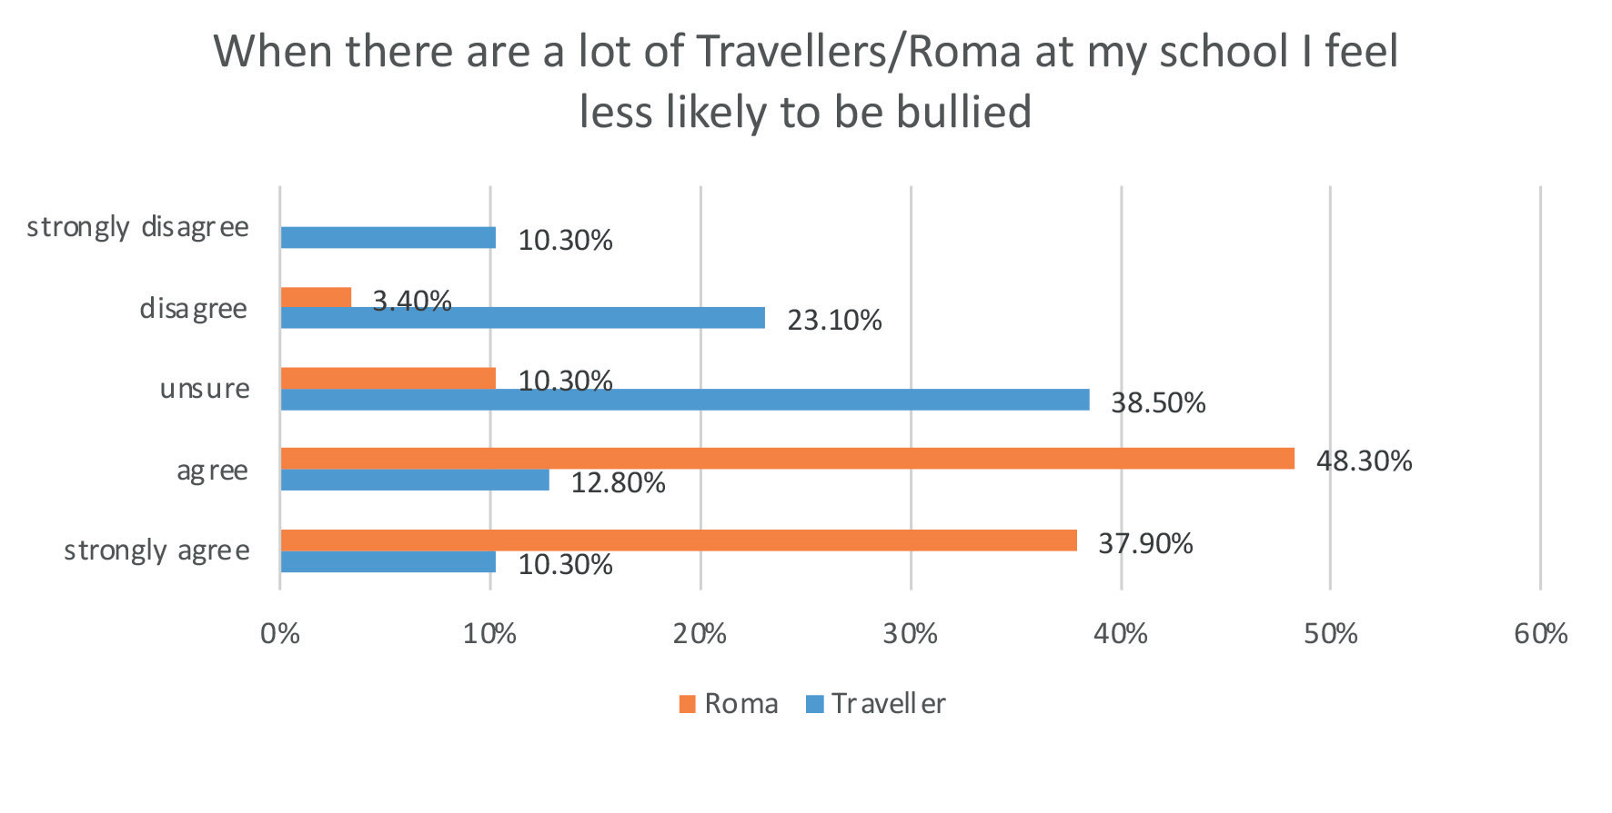
Figure 2.9: Participants’ perceptions of whether the proportion of fellow ethnic group members in their school influenced their risk of being bullied (n=68)

Perpetrators of bullying

Of those that reported being bullied: both boys and girls were identified as bullies; most participants were bullied by a peer (or peers) in their own class; and settled children were most commonly named as perpetrators of bullying.

Bullying by teachers

All participants were asked whether they had been bullied by teachers and there were reports of being bullied by teachers across two secondary schools and one primary school. Five Travellers (12.2% of Travellers surveyed) indicated that they had been bullied by teachers several times a week at some point in the past year. However, they were not asked how long such bullying lasted. None of the Roma participants reported that they had been bullied by teachers but one Roma pupil perceived that Irish children sometimes received preferential treatment and that she was treated differently.

Four of the Traveller pupils expanded on how they were bullied by teachers and described incidents of verbal abuse and how teachers made them feel unwanted and excluded. One of the post-primary female Travellers described how “Teachers call us knackers to our faces and scream at us.”

Another secondary school female Traveller student said “the principal and teachers have told other students not to hang around with me.” The same student explained teachers’ attitudes towards her and
other Travellers in her school.

Principal is more focused on getting me out. Getting ignored, accused of stealing made to feel like we don’t belong. One teacher said you are 16 now you can leave you don’t have to be here.

Two Traveller post-primary school male pupils described how they were not allowed to go to the toilet. One recounted how teachers were mean. They talk about Travellers. The other boy described being ignored by teachers and being placed on reduced timetable.

Another Traveller primary school pupil described how the teacher is a bit evil to one Traveller girl. She said the teacher does not expect much of the little girl and is not nice to her. She also commented that when the girl’s mother complained the teacher denied it.

Reporting bullying

With respect to pupils who were bullied, participants most frequently confided in an adult (such as their teacher, another adult at school, or their parents). Three out of the four Roma pupils, who were bullied, reported it to their classroom teacher. Yet only 3 out of the 9 Travellers who experienced bullying told their teacher. While seven (out of 9) Traveller pupils told their parents about being bullied, none of the Roma pupils did. Pupils also confided in: another adult at school (n=3); siblings (n=2), friends (n=3) and the guards (n=1). One of the Traveller pupils who was being bullied by teachers did not tell anyone.

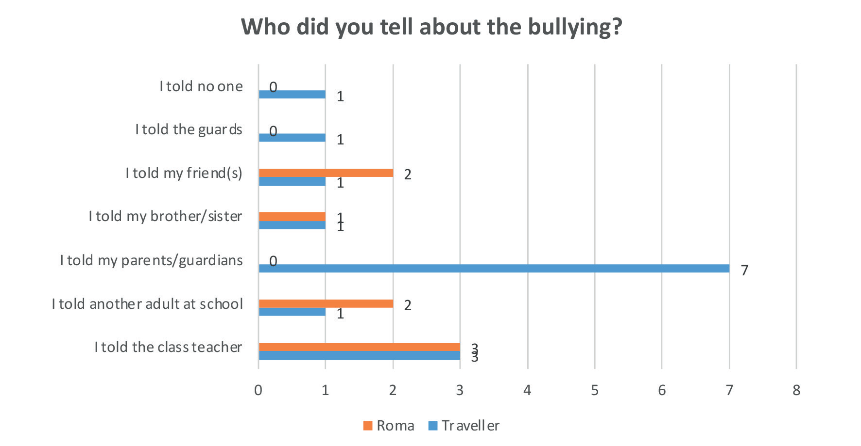
Figure 2.10: Participants’ reports of persons they told about the bullying (n=13)
*7 participants told more than one person

When probed whether any adult at home contacted the school to try to stop the pupil being bullied, three Traveller and two Roma pupils said the adult did contact the school once with a further three Travellers saying their parents contacted the school several times.

Reasons for not reporting bullying

There were four reasons offered for not reporting bullying. Respondents said they did not report bullying to a teacher because: they were worried about being called a tell-tale (n=1); they were not confident that they would be believed (n=1); the teacher didn’t take their concern seriously (n=1); and the teachers (and in one case the teachers and the principal) were doing the bullying (n=5).

One Traveller girl elaborated on her experience of reporting bullying “the teacher told me the girl was nice and so I wouldn’t tell the teacher anymore”.
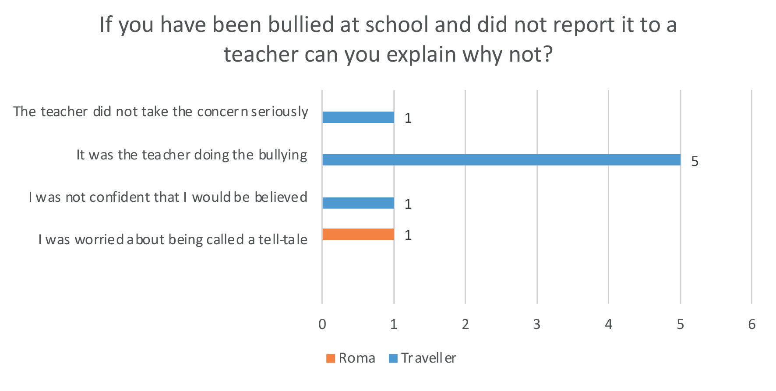
Figure 2.11: Participants’ reasons for not reporting bullying to a teacher (n=8)

Response to bullying

Six survey questions investigated pupils’ perceptions regarding the school response to bullying. For those that experienced bullying, they were asked: what teachers did to try and put a stop to bullying; how happy they were with the teacher’s response; and how helpful they perceived the teacher to be. In addition, all participants were also asked more general questions regarding how often staff or other students try to put a stop to bullying.

Teachers’ response

Among the six respondents who reported bullying to their teacher, four participants described multiple actions taken by the teacher. The most frequent response to bullying was the teacher talking to the pupil about what happened, who bullied them, where, when and why (n=5). Additional actions included: writing down the pupil’s account of what happened (n=1); talking to the person who bullied them about what happened, who, where, when and why (n=2); writing down the bully’s account of what happened (n=1); contacting the pupil’s parents (n=2) contacting the bully’s parents (n=2). One Roma child’s comments indicated that the teacher was quite thorough in his/her response. According to the child, the bully was punished, the teacher followed up with them to ask whether the bullying had stopped and reported the bullying to the principal. None of the participants noted that the teacher followed up with the bully to ask whether the bullying had stopped, and one Traveller girl outlined that the teacher did nothing much only told the girl to say sorry.

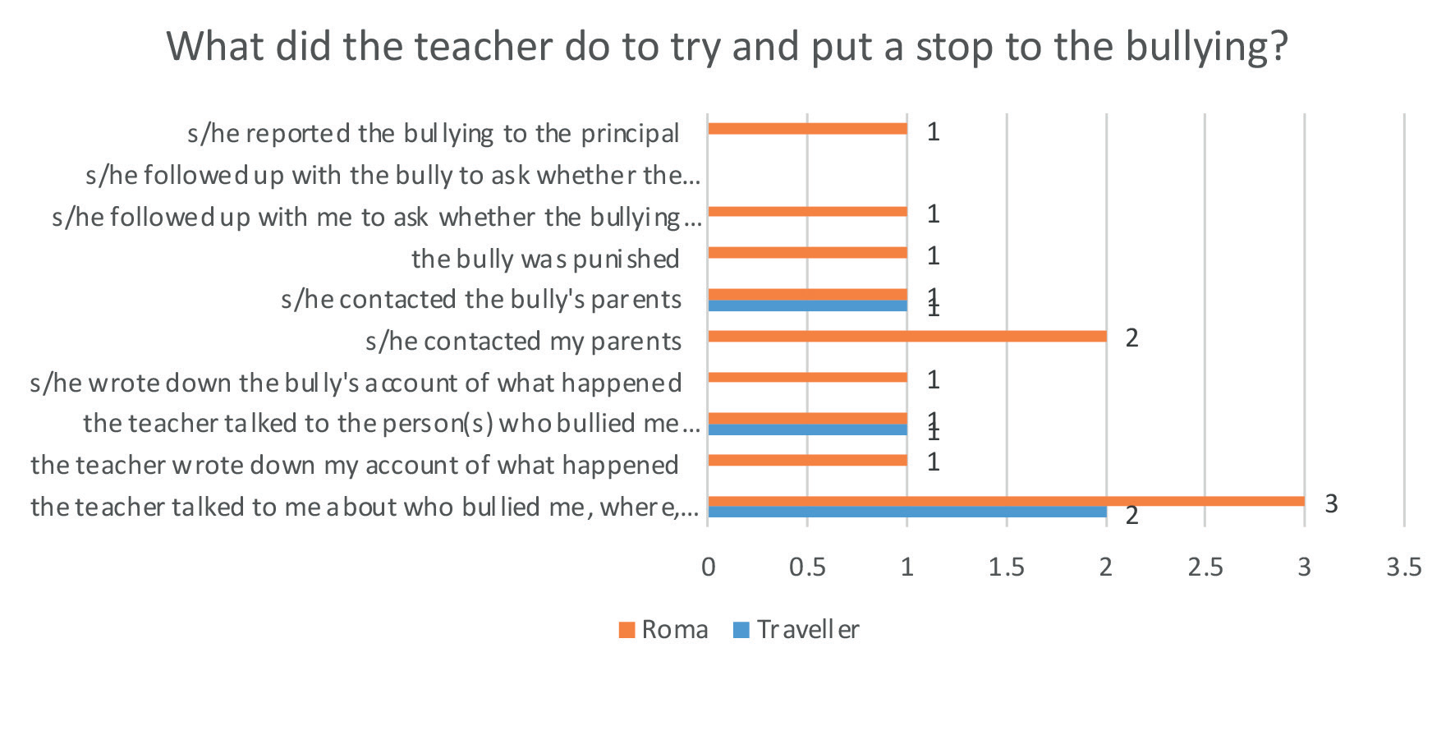
Figure 2.12: Participants’ description of actions taken by the teacher following a report of bullying (n=6)

Pupils’ perceptions of teacher/school response to actual bullying incident

In terms of pupils’ satisfaction with the teachers’ handling of the bullying, there were responses from eight participants. Three Roma pupils reported that they were very happy with the teacher’s response. One Traveller said that they were happy with the handling, another was unsure and three Travellers reported that they were very unhappy with the teacher’s response to bullying. It is unsurprising that one of these Traveller pupils was very unhappy with the teacher’s response as her concern was not taken seriously when she reported bullying by another student. The other two Traveller pupils (who were very unhappy with the teacher’s response) were being bullied by teachers (and students). However, it is important to note that these two pupils did not report that they were being bullied and therefore teachers were not in a position to respond to allegations.

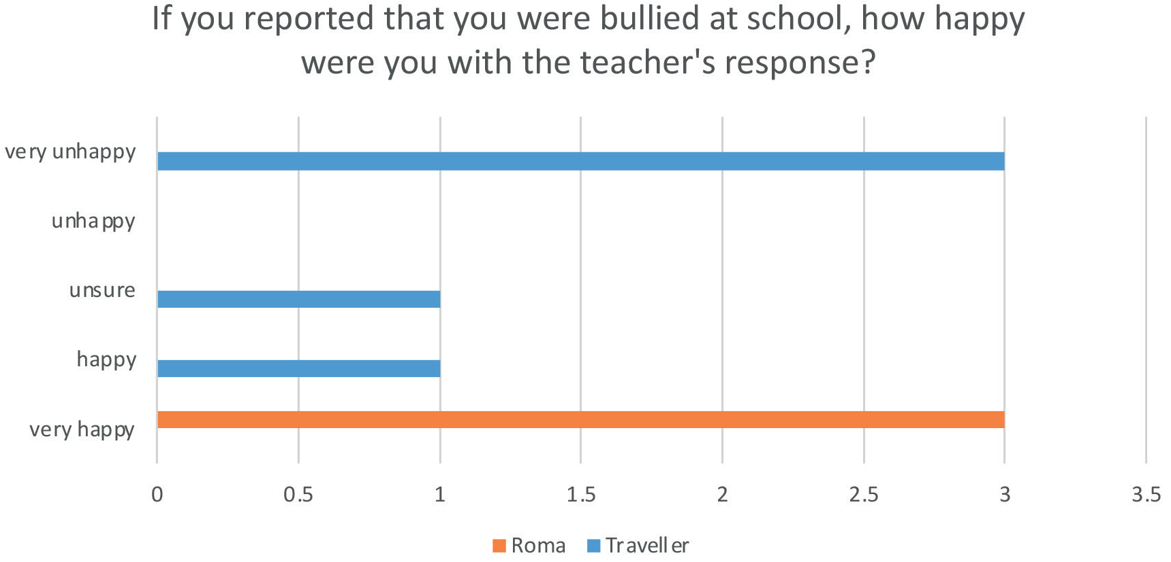
Figure 2.13: Participants’ happiness with the teacher response to bullying (n=8)

Similarly, participants were also asked to consider how helpful they perceived the teacher to be at putting a stop to the bullying. There were responses from nine pupils. Five pupils (two Travellers and three Roma) reported that the teacher was very helpful at putting a stop to the bullying. One Traveller pupil characterised the teacher as helpful. Three Travellers emphasised that the teacher was very unhelpful at putting a stop to the bullying. Again these comments came from the pupil whose concern was not taken seriously and the pupils who were being bullied by teachers and students but did not report the bullying. Perhaps their decision to emphasise that they found teachers very unhelpful reflects their general frustration and upset.

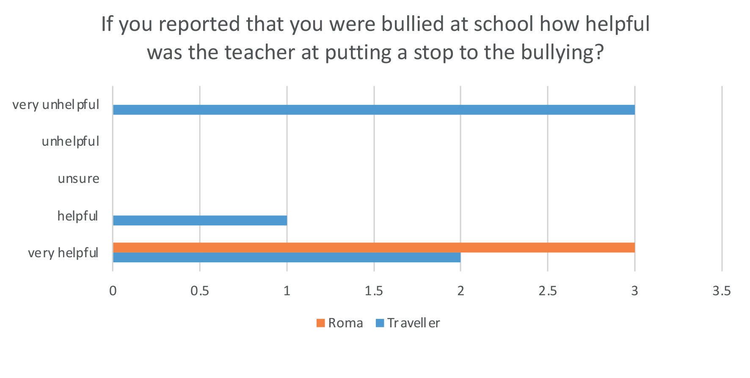
Figure 2.14: Participants’ perceptions of teacher effectiveness with regard to putting a stop to bullying (n=9)

The anti-bullying procedures emphasise the role and responsibility of school staff, and indeed pupils, in helping the school to prevent and address school based bullying behaviour. Therefore, all participants were asked to consider how much they thought their class teacher and fellow students had done to put a stop to bullying over the past year.

Perception of whether teachers put a stop to bullying in general

Just over half, of pupils surveyed, said their perception was that, in general, teachers almost always try to put a stop to a student being bullied (50.7%, n=36) and a further 12.7% (n=9) reported that teachers often try to put a stop to bullying. Others were less convinced by teachers’ efforts with 1.4% (n=1) estimating that teachers try to put a stop to bullying once in a while and another 1.4% (n=1) saying teachers intervened sometimes. Sadly, 5.6% (n=4) felt that teachers almost never try to put a stop to a student being bullied and another 5.6% (n=4) emphasised that teachers never put a stop to the bullying with one saying it is the teachers doing it. Similarly, one Roma pupil claimed that the teacher is
racist and the pupil can’t tell anyone.

Almost one fifth of participants (n=14 Travellers) skipped the question. One respondent commented that they had not seen anyone being bullied in school so couldn’t answer the question. Perhaps this observation accounts (in part) for some Traveller participants’ failure to offer their perception.

Overall the results suggest that Travellers have somewhat less confidence than Roma pupils that appropriate action will be taken by teachers. Perhaps this is due in part to Traveller participants’ experience of being bullied for relatively longer duration along with their experience of being bullied by teachers.

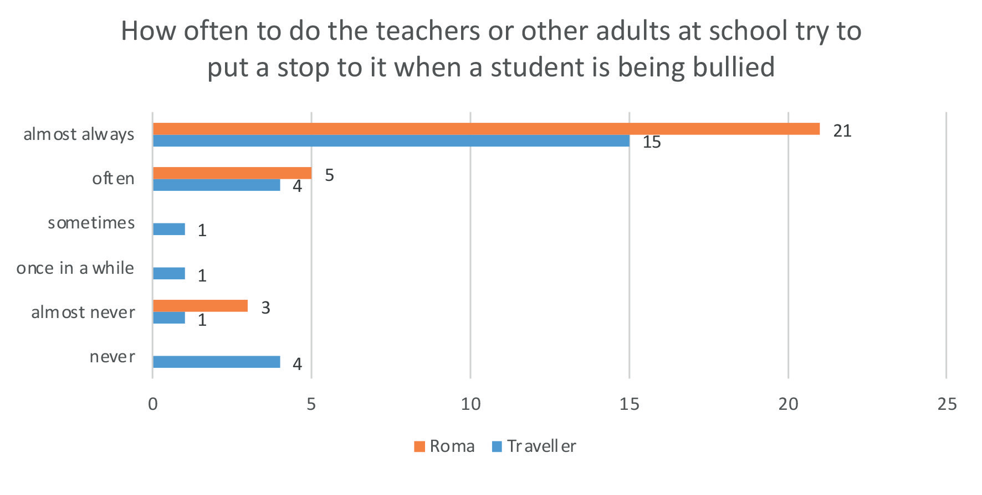
Figure 2.15: Participants’ perceptions of how often teachers try to put a stop to bullying in general (n=57)

Perception of students putting a stop to bullying

Similar to above, the following question attempted to capture the climate of the school in relation to attitudes towards and/or tolerance of bullying. With respect to fellow students trying to putting a stop to a student being bullied, only 40.8% (n=29) of participants perceived that students ‘almost
always’ made an effort to address bullying with a further 8.5% (n=5) indicating that their perception was that this ‘often’ happened. A proportion of pupils were less confident about student intervention with 14.1% (n=9) estimating it happened ‘sometimes’ and 4.2% (n=3) thinking it occurred ‘once in a while’. Lastly, 11.3% (n=8) felt that students almost never intervened. One possible reason for reluctance was suggested by a Roma pupil who explained that students don’t want to get involved but they tell the teachers.

The results suggest that Roma pupils have a somewhat more optimistic view than Travellers that their peers would intervene if they witnessed another student being bullied. However, 14 Travellers skipped the question so no definitive conclusion can be drawn.
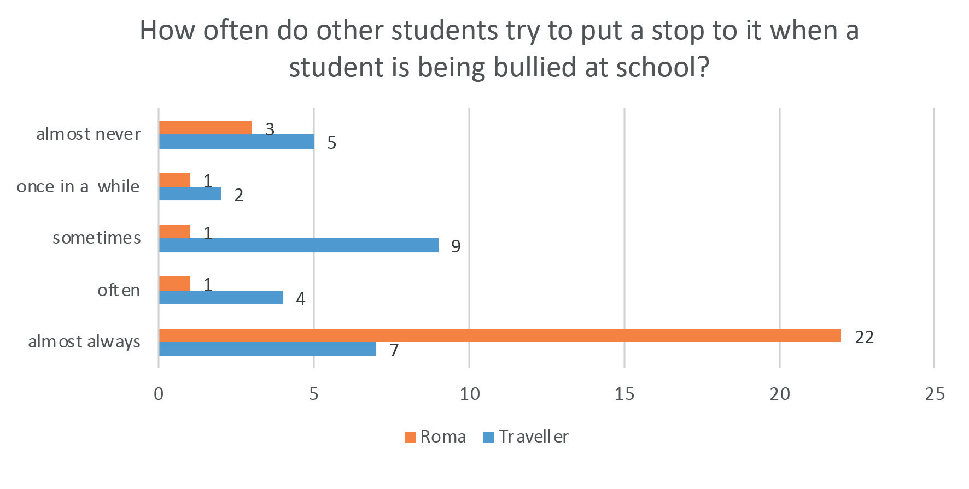
Figure 2.16: Participants’ perceptions of how often other students try to put a stop to bullying in general (n=57)

Bullying prevention approaches in use in schools

All participants were asked what their school does to help pupils recognise and deal with bullying. They were provided with a list of options and could tick all that applied. Participants could also insert additional responses. The most frequently reported strategies to raise awareness of bullying were displaying information on bullying around the school building (63.4%, n=45) and including the school rules in notebooks and/or around the school building (59.2%, n=42). With respect to preventing bullying, more than half of the participants affirmed that they are encouraged to respect people who are different to them (57.7%, n=41). On the issue of addressing bullying, just over half of the respondents acknowledged that they are taught what to do if someone they know is being bullied (54.9%, n=39) and just over a third commented that during lessons they learn how to recognise and cope with bullying (36.6%, n=26).

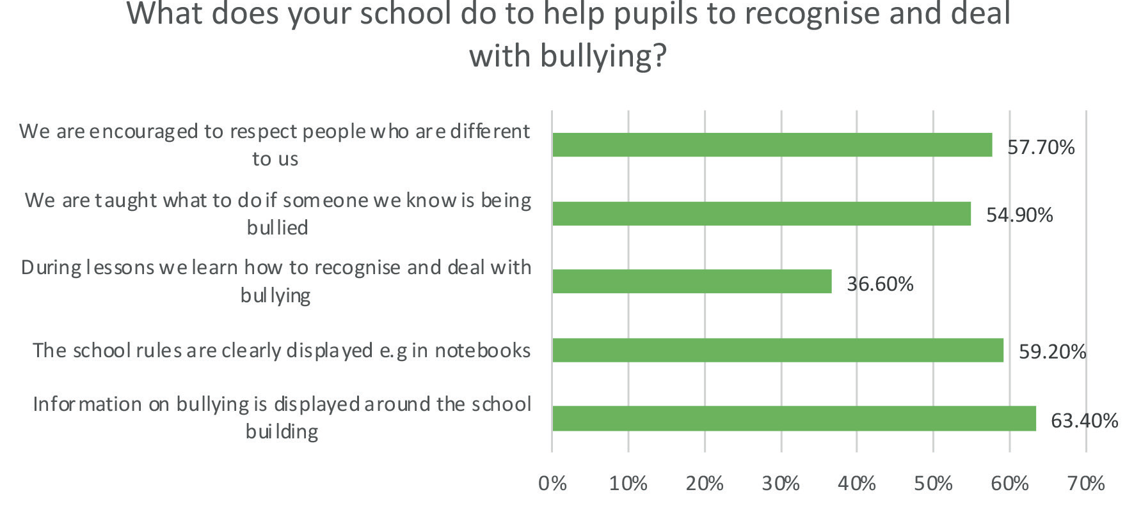
Figure 2.17: Participants’ reports of what their school does to help pupils to recognise and deal with bullying (n=71)

Some students specified additional approaches that are employed in their school such as: anti-bullying week; the principal talking about bullying in assembly; giving an anonymous note to say if you are being bullied; and being tested on what to do if someone is being bullied.

Two Traveller second level students explicitly stated that they don’t know what their school does to help pupils recognise and deal with bullying. This is concerning because both students reported being bullied on a regular basis by teachers in one case and by teachers and pupils in the other case. Another Traveller second level student acknowledged that information on bullying is displayed around the school building yet it doesn’t make a difference when the teacher was at it (the bullying).

Reported impact of bullying on participants

Several participants who were bullied revealed the severe impact of their experience of bullying on their: emotional well-being; ability to concentrate; sense of inclusion and belonging; attendance; wish to complete school; experience of sanctions; and most worryingly their mental health.

Two Roma primary school pupils described feeling sad and worried. They both reported that the bullying made it difficult for them to pay attention and concentrate in class.

There were comments about feeling excluded and unwanted from two Travellers. One primary school pupil elaborated how she doesn’t play with the girls in her class. Most of them don’t want to play with me. Another second level student Traveller described how the teacher made him feel unwanted.

“The teachers wouldn’t teach me anything and gave me work for small kids and wouldn’t let me use the toilet.”

The impact on school attendance and school completion was also apparent in the pupils’ comments. One teenage Traveller who reported being bullied by teachers and students said he left because of the
bullying. I am going to Youthreach. Similarly, one second level Traveller student described the impact of teachers bullying her.

“It is affecting me wanting to go to school. I used to love school. They keep trying to push us out of school and trying to get me to do LCA when I am capable of doing normal leaving cert. I feel unwanted in school.”

Alarmingly, one Traveller second level student, who reported being bullied by pupils and teachers, said “I have been left suicidal. I can’t take it anymore.”

There were also reports of being suspended from two of the above Traveller pupils. One post-primary pupil described being annoyed because “I was suspended because I eventually fought back.”

3. Traveller and Roma pupils’ experiences of discrimination

Following the bullying questionnaire, pupils were asked to complete a perceived discrimination scale that investigated the degree to which they felt that they, or members of their community, had been discriminated against by peers and teachers at school. Seventeen (out of 42) Traveller pupil participants and all 29 Roma participants responded to the questions. The scale was based on a scale used by Wong, Eccles and Sameroff (2003) and then adapted following the pilot study to be
more relevant to the age and context of the target pupils. The scale included ten questions asking respondents to rate how frequently they or their ethnic group members had experienced different forms of discrimination from their peers and teachers. Pupils were read five examples of discriminatory behaviour by peers such as name calling and exclusion and asked how often they had experienced this behaviour. They were read examples of teacher discrimination such as being left out or unchallenged. Lastly, they were asked how often their Traveller/Roma peers (as applicable) experienced name calling, exclusion and physical aggression.

It was hoped that the results of the scale would provide some insight into the school culture and climate in surveyed pupils’ schools. A positive school culture and climate that is welcoming of difference and diversity is considered a cornerstone in the prevention of bullying.

Perceived discrimination scale findings

The results suggest that only Roma students experience their non-Roma peers saying they don’t belong in Ireland. One Roma pupil said it happened once and another commented that “it used to happen but not anymore.”
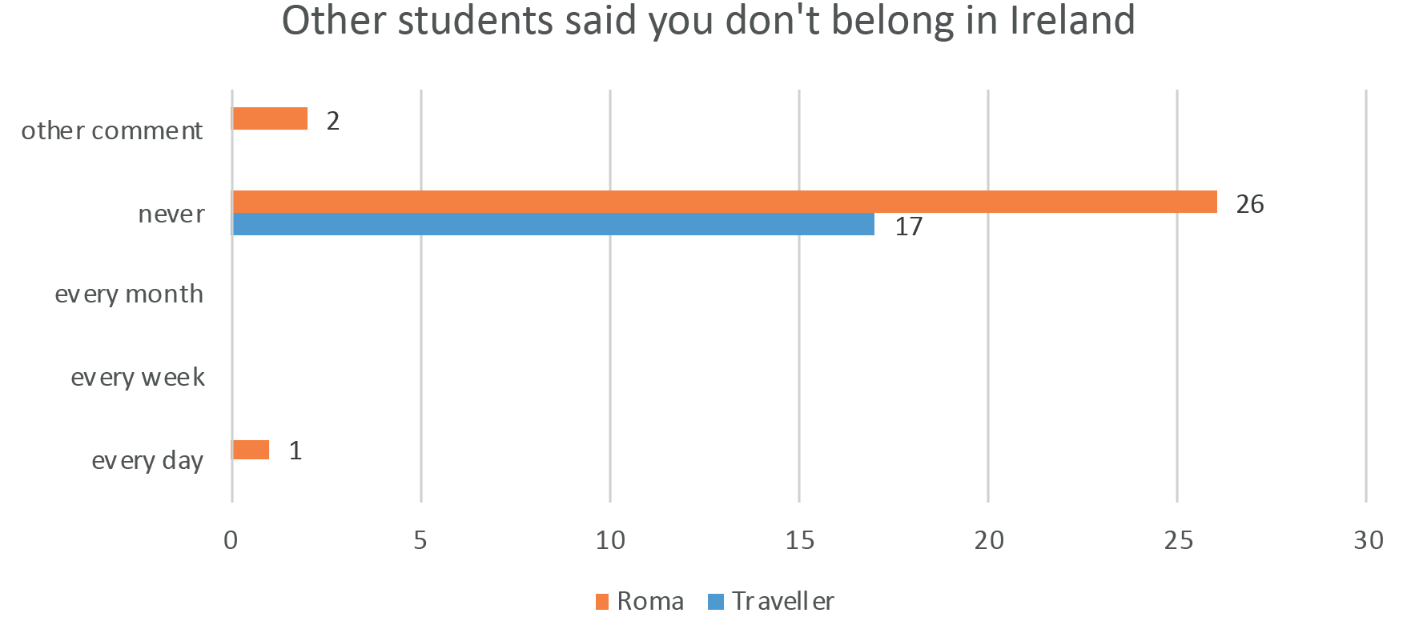
Figure 3.1: Participants’ perceptions of how often other students said they don’t belong in Ireland (n=46)

The two charts below illustrate respondents’ perceptions that others didn’t want to play with them or left them out because of their ethnicity. Traveller pupils reported more frequently than Roma that others didn’t want to play with them or left them out because of their ethnicity. One Roma pupil
acknowledged that it used to happen (that others didn’t want to play with them and they were left out) and another reported that they were left out once or twice.

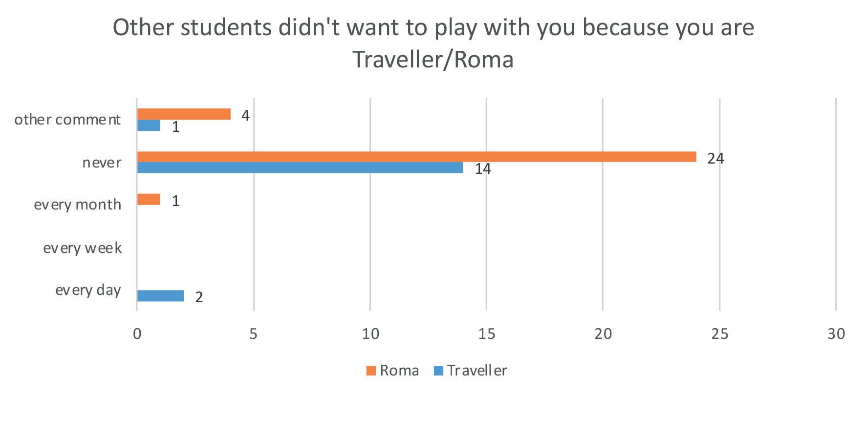
Figure 3.2: Participants’ perceptions of how often other students didn’t want to play with them because of their ethnic group membership (n=46)

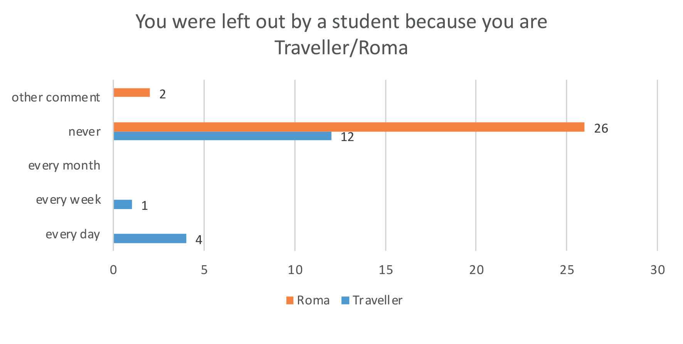
Figure 3.3: Participants’ perceptions of how often they were left out by a student because of their ethnic group membership (n=45)

With regard to name calling, two Travellers indicated that they were teased about being a Traveller every day. Two Roma pupils said that it happened sometimes and another one explained that it used to happen.
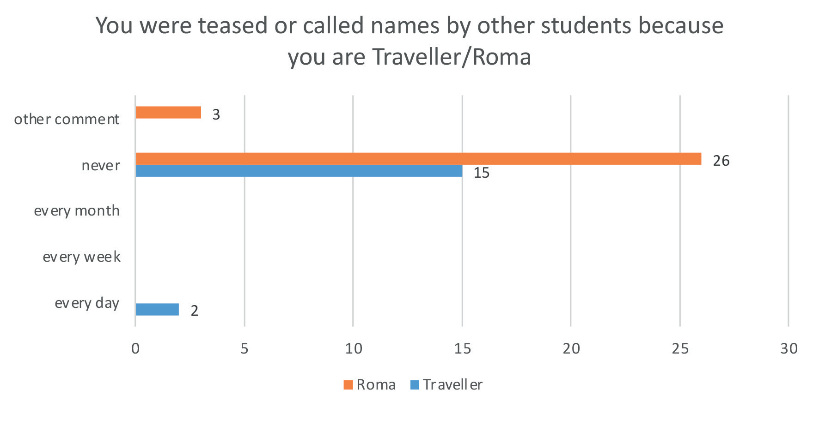
Figure 3.4: Participants’ perceptions of how often they were called names by other students because of their ethnic group membership (n=46)

Physical types of aggression were less frequently reported than relational aggression such as exclusion. Two of the Travellers surveyed said that they were spat on, pushed or hit by other students because they are a Traveller. None of the Roma pupils indicated that they experienced this form of harassment.

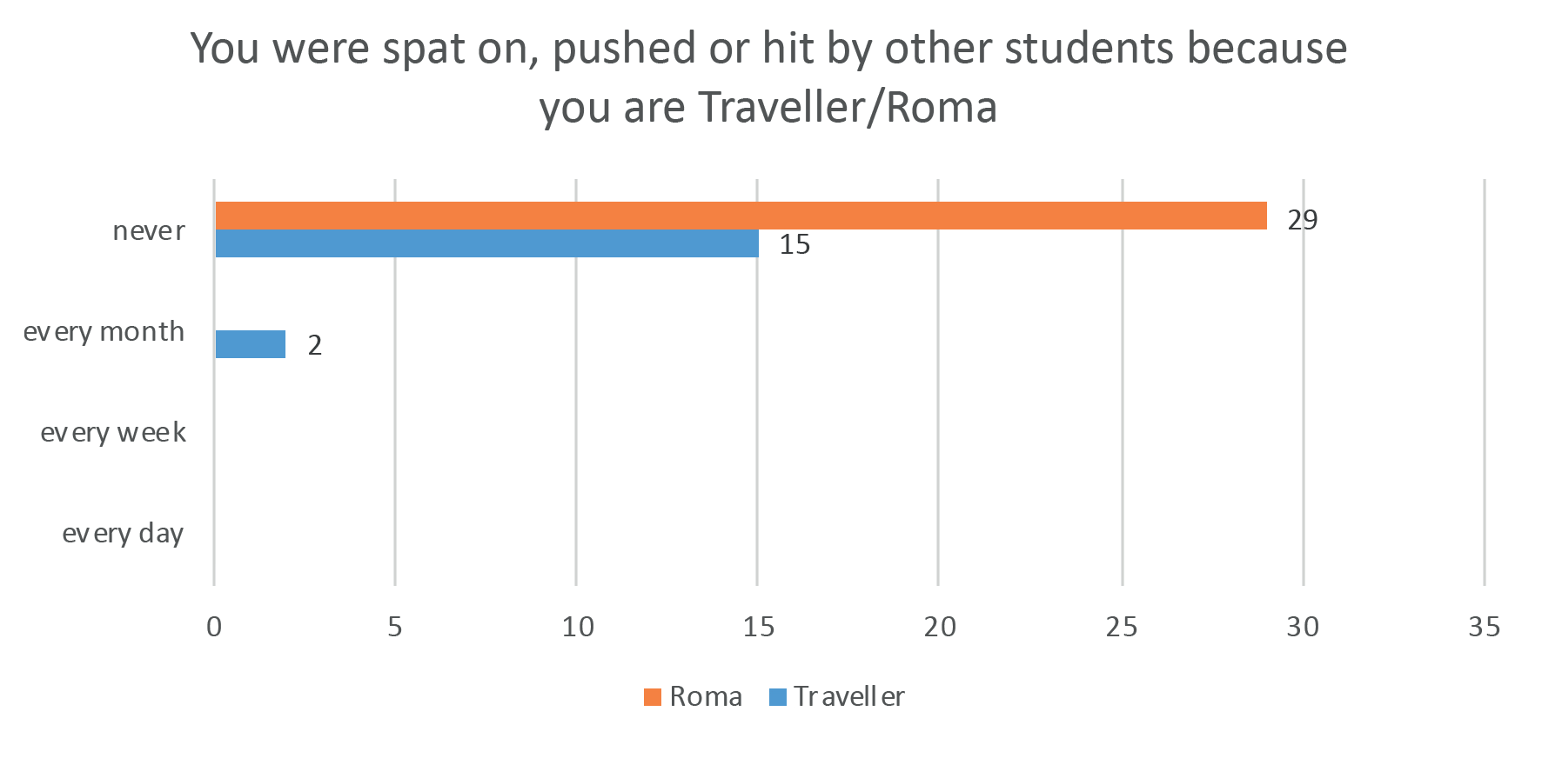
Figure 3.5: Participants’ perceptions of how often they were spat on, pushed or hit by other students because of their ethnic group membership (n=46)

Students were asked not just about their personal experience of discrimination but also that of their Traveller and Roma peers. The results revealed that six, out of the seventeen Travellers surveyed, observed their Traveller peers being left out with varying degrees of frequency and five indicated that fellow Travellers were frequently teased and called names because they are members of the Traveller community. Four Roma pupils felt that Roma were left out sometimes and one was not sure. Similarly, five Roma pupils explained that Roma are sometimes called names. One Roma student added that one pupil “gets called names because she starts calling others names first.” Another Roma pupil elaborated that “it doesn’t happen much in my school because they are afraid of the older Roma boys to pick on the new ones”

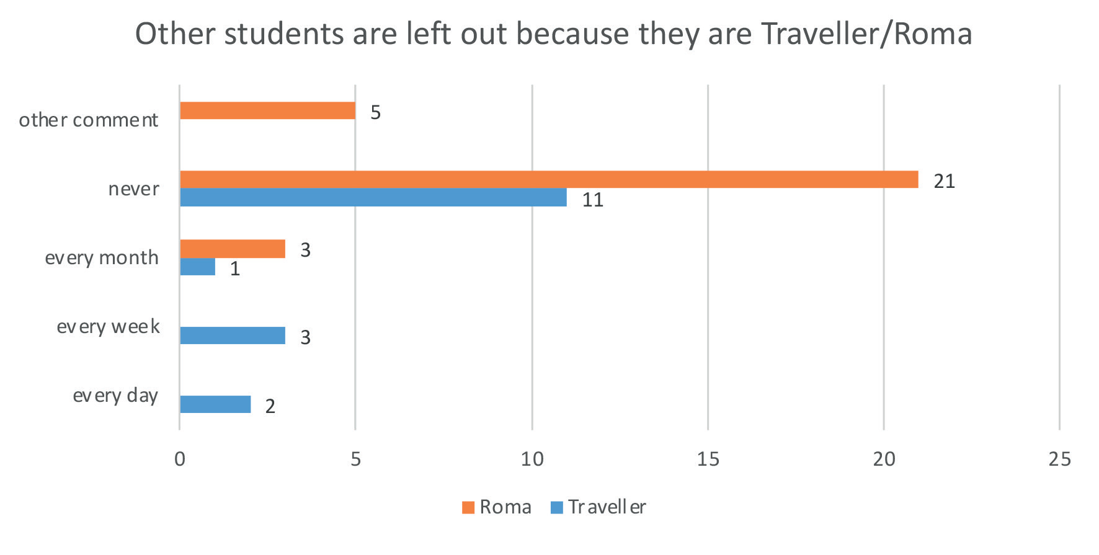
Figure 3.6: Participants’ perceptions of how often other students left them out because of their membership of the Traveller/Roma community (n=46)

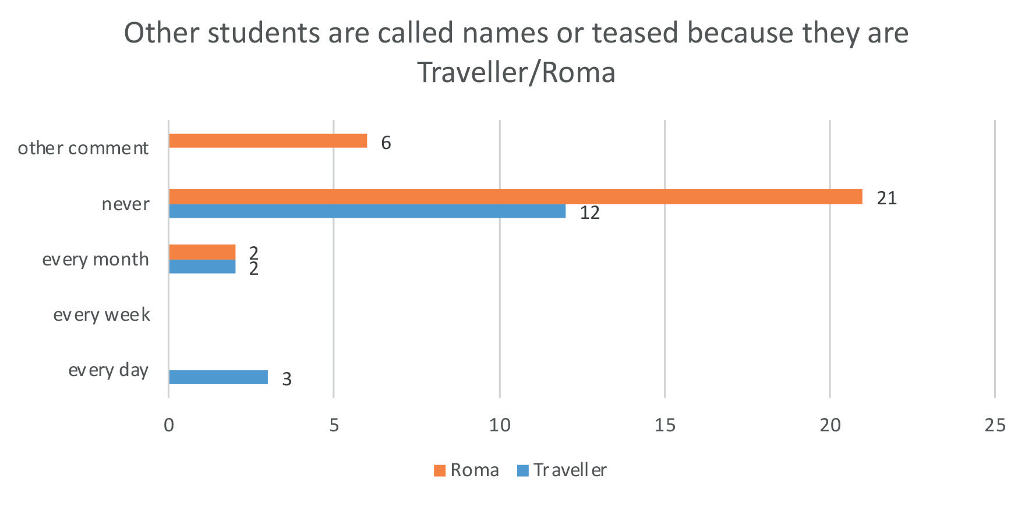
Figure 3.7: Participants’ perceptions of how often other students are called names or teased because of their membership of the Traveller/Roma community (n=46)

More overt forms of aggression such as pushing and hitting were less frequently witnessed by students. However, two Travellers perceived that this happened every day. Two Roma said they think it sometimes happened with one stating that they “heard it happened.” Another Roma pupil was unsure.

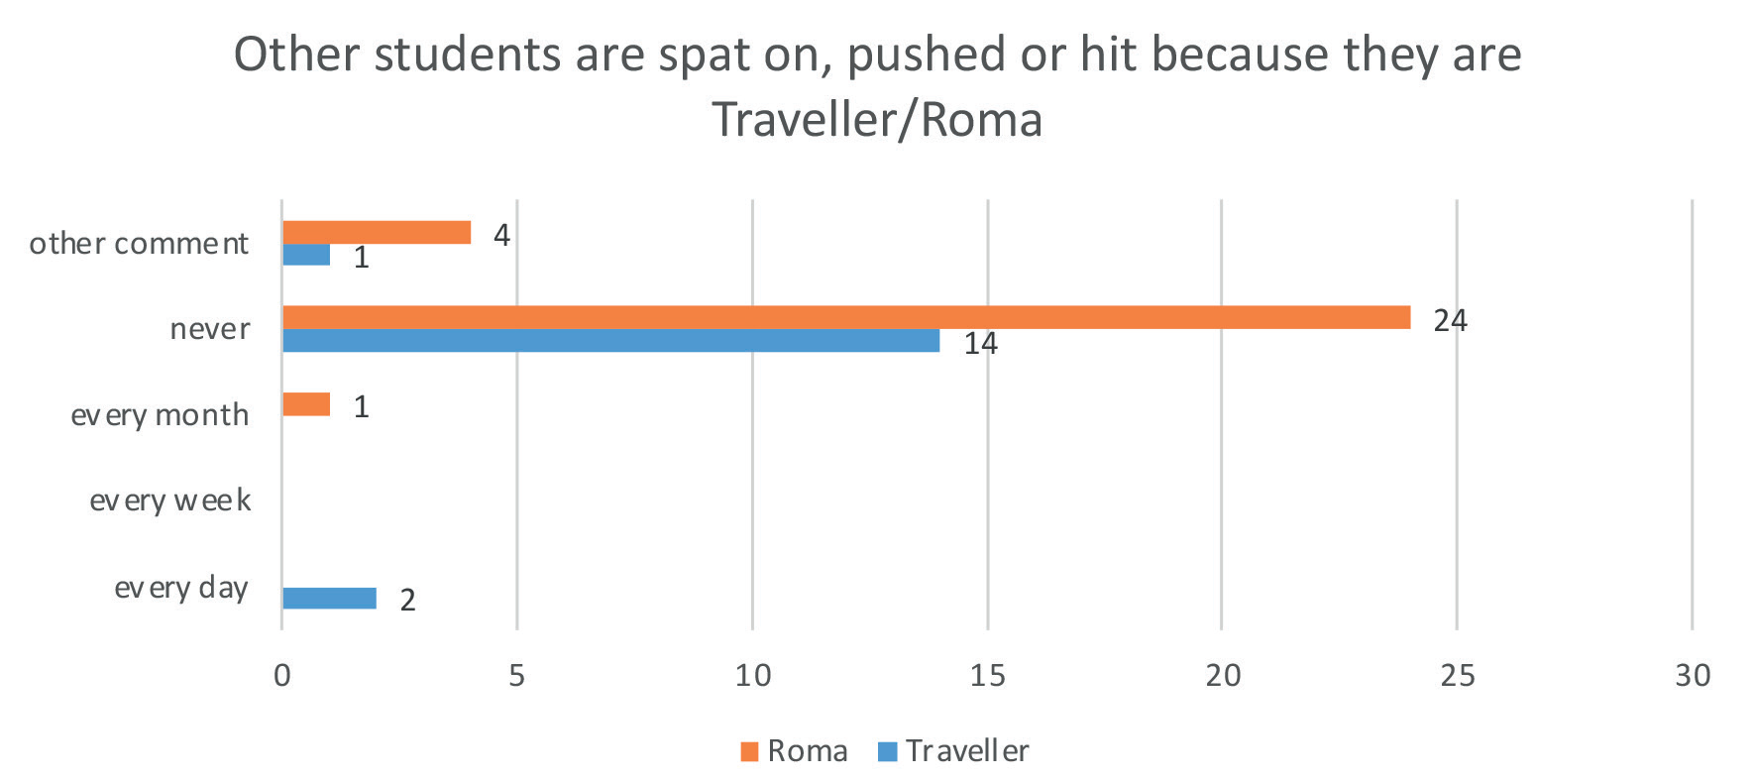
Figure 3.8: Participants’ perceptions of how often other students are spat on, pushed or hit because of their membership of the Traveller/Roma community (n=46)

Teacher behaviour towards pupils is an important indicator of school culture and climate. Thus, pupil participants were asked about teacher expectations and whether they ever felt left out by a teacher. None of the Roma pupils reported perceiving that their teacher thought they couldn’t do something because of their ethnic group membership. The same applied for fourteen of the seventeen Traveller pupils who completed the scale. However, two of the seventeen Travellers who completed the scale felt that teachers frequently communicated low expectations and another didn’t know whether their teacher had low expectations. Five Travellers felt that they were frequently left out by teachers, whereas none of the Roma pupils reported this.

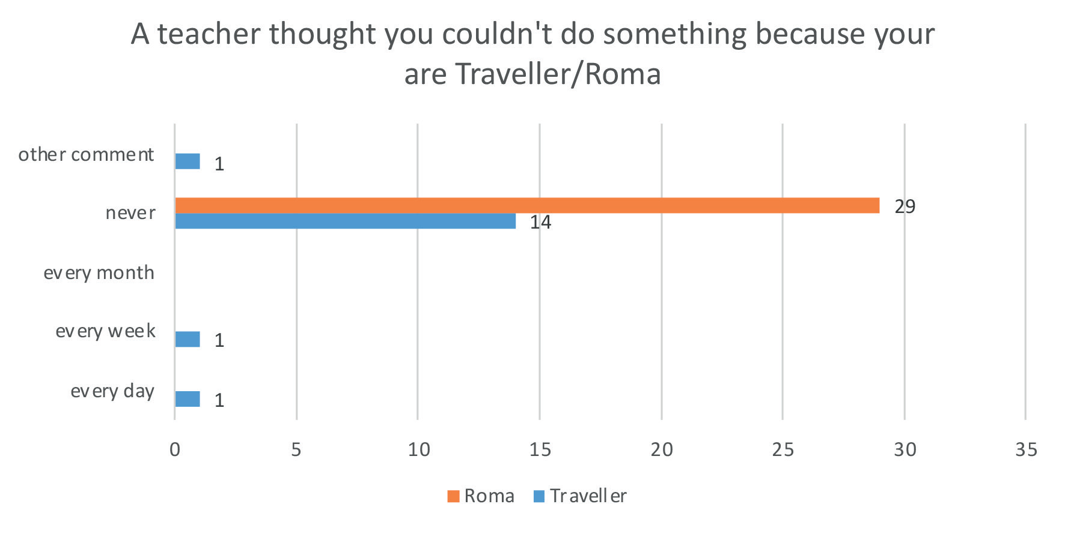
Figure 3.9: Participants’ perceptions of how often a teacher thought they couldn’t do something because of their membership of the Traveller/Roma community (n=46)
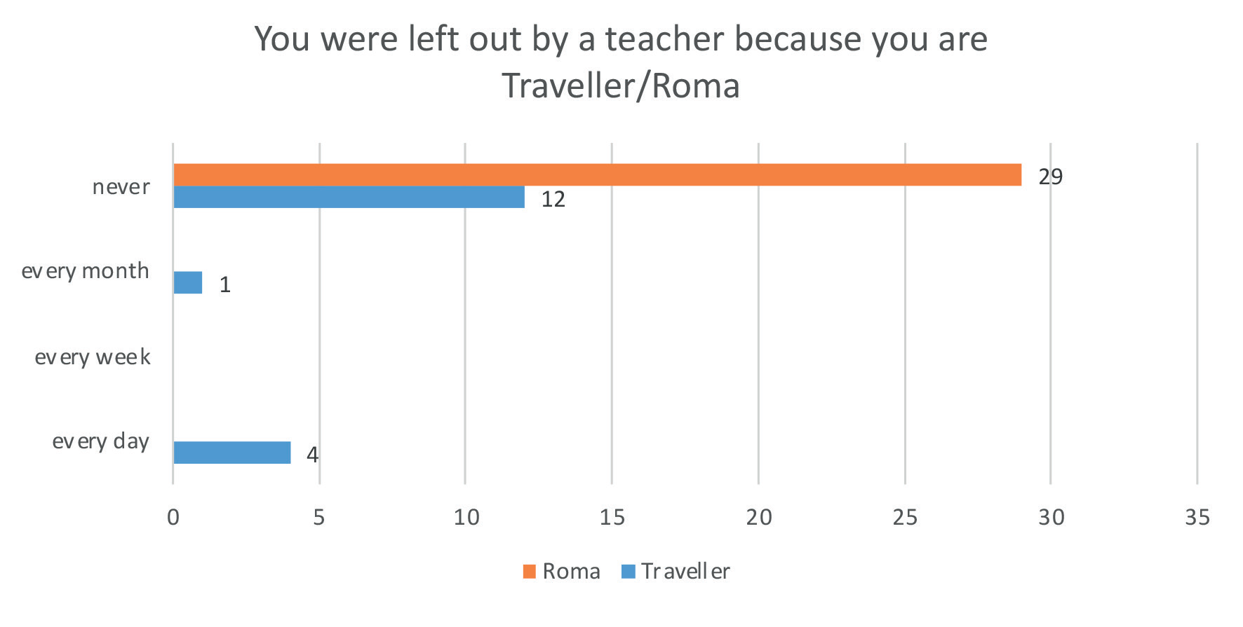
Figure 3.10: Participants’ perceptions of how often they were left out by a teacher because of their membership of the Traveller/Roma community (n=46).

4. Traveller and Roma parents’ perspectives on their children’s experience of bullying in school

Parent survey

In order to gain an additional perspective on the effectiveness of the anti-bullying procedures, Traveller and Roma parents were also invited to offer their insight into their children’s experiences in the school system.

Description of Parent survey

The parent survey was designed by researchers at DCU’s National Anti-Bullying Research and Resource Centre. It included questions about the age, gender and ethnicity of the parent’s child, and how much they thought their child likes school. Parents were also asked about their child’s experiences of bullying (specifically the frequency of bullying) in the previous year. They were asked a series of questions about contacting the school to report bullying and possible reasons they might not have reported incidents of bullying. Their perceptions of the school’s handling of bullying were also sought along with a description of what their child’s school does to help parents recognise and deal with bullying. Parents were asked to rate how satisfied they were with the school response and how helpful they perceived the school to be with respect to putting a stop to the bullying. The survey concluded by seeking parents’ views on how their child’s experience of bullying affected their participation in school.

Parent participant profile

Sixty-two parents (32 Traveller, 29 Roma and one settled) took part in the survey. Parent participants’ children ranged in age from four to eighteen with an average age of 12.5 years and a median age of 12.

Parent perceptions of how much their child likes school

Most parents reported that their child either likes school (37.7%) or likes school very much (29.5%). Some parents felt that their child neither liked nor disliked school (16.4%) and unfortunately a proportion of parents indicated that their child either disliked school (9.8%) or disliked school very much (6.6%).

One parent of a child from a mixed marriage (marriage between a Settled person and a Traveller person) added that her “child loves learning but has a hard time at play time.”

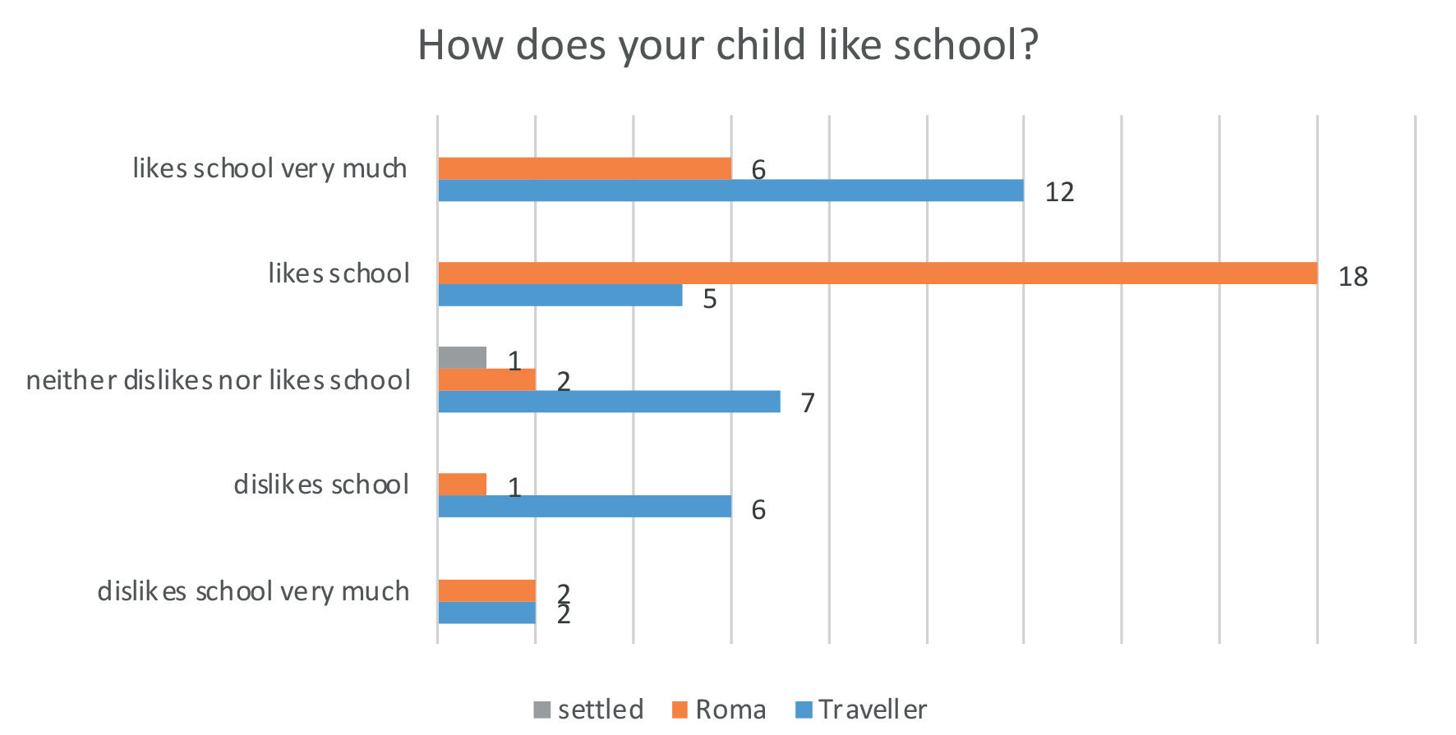
Figure 4.1: Parents’ perceptions of how much their child likes school (n=61)

Parents’ reports of their child’s experience of bullying at school
Parents were provided with a definition of bullying (the same definition as provided to pupils) and asked how often their child had been bullied at school in the past year. A large majority of parents surveyed (88.5%) reported that their child had not been bullied at school in the previous year. However, 6.5% of parents recounted that it only happened once or twice with a further 3.2% stating that it happened 2 or 3 times a month and 3.2% described how their child was bullied several times a week. There was a comment from one parent of a primary school pupil stating that her daughter was

“bullied before by a young girl when she was in younger classes She is a child of a mixed marriage and finds it hard from both sides, both Traveller and settled child she is in no man’s land.”

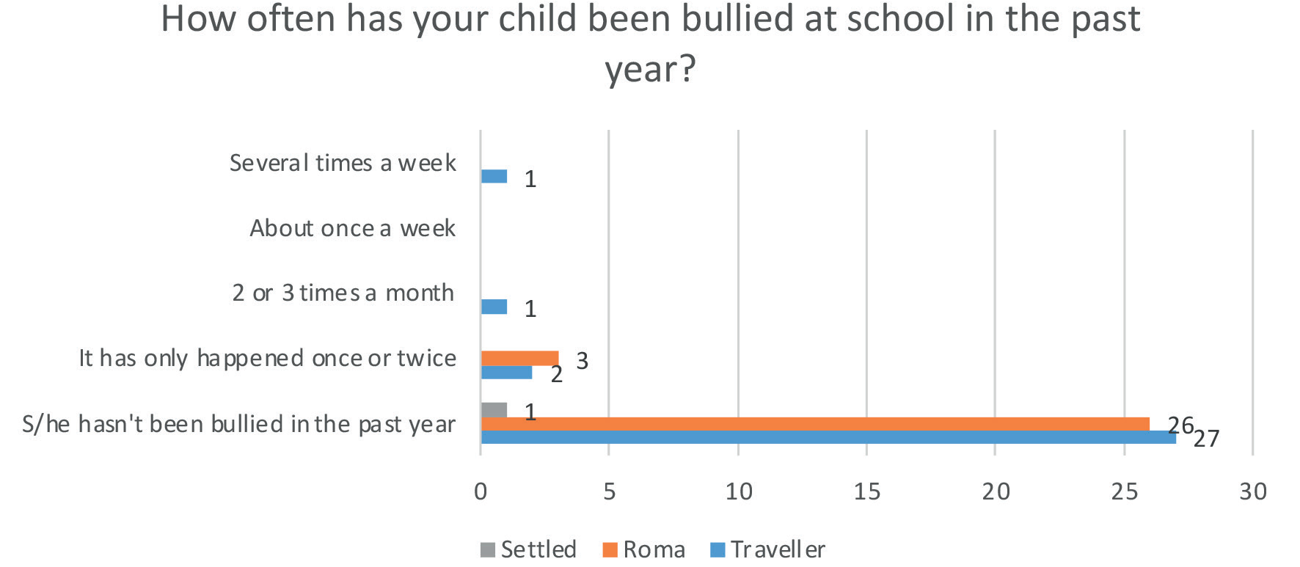
Figure 4.2: Parents’ reports of how often their child was bullied at school in the year prior to the study (n=61)

Parents’ experience of reporting bullying
Of the parents who responded that their child had been bullied in the previous year, none of the three Roma parents and only three (out of four) Traveller parents indicated that they contacted the school to try to stop their child being bullied at school. Among the Traveller parents, one Traveller grandparent contacted the school several times following concerns that their grandchild was being bullied by pupils and teachers and two Traveller parents contacted the school once after their child was bullied once or twice.

Parents offered a number of reasons for not contacting the school following a bullying incident: they were afraid that the bullying would get worse (n= 1 Roma parent); they didn’t have any proof or evidence that their child was being bullied (n=1 Traveller parent); they were worried that their child would be blamed for being bullied (n=1 Roma parent); and they didn’t think the school would do anything to stop the bullying and the children would be suspended (n=1 Traveller grandparent). In the latter case the Traveller’s post-primary school grandchild was being bullied by pupils and teachers and was suspended.

Parents’ reports of the school response to bullying
Parents were asked if they reported that their child was bullied at school what did the school do to try to put a stop to the bullying. None of the Roma parents reported bullying to the school, therefore only Traveller parents identified procedures that were employed to investigate and deal with bullying.

The grandparent of a post-primary school pupil who was being bullied by pupils and teachers described how the teacher/principal talked to them and their grandchild about what happened, who bullied him/her, when and why. The teacher/principal also wrote down their respective accounts of
what happened. In this case the teacher also talked to (and recorded the account of) the person(s) who bullied their child about what happened, who, where, when and why. However, the grandparent explained that their “grandchild was blamed, they believed the bully. The guards were rang and still nothing happened. It’s still ongoing. My grandchild was suspended for days.”

The parents of three primary school Traveller pupils who were bullied once or twice also described the school response. One commented that the teacher/principal talked to them about what happened, who bullied him/her where, when and why. Another indicated that the teacher/principal wrote down their account (along with the bully’s account) of what happened. Lastly, one parent reported that the teacher/principal talked to the person(s) who bullied their child about what happened, who, where, when and why and the bully was punished.

According to the anti-bullying procedures, follow up meetings with relevant parties should be arranged. However, none of the parents (of the three who responded that their child had been bullied in the past year and that this had been reported to the school) indicated that anyone followed up with either themselves, their child, or the bully to ask whether the bullying had stopped.

The anti-bullying procedures also specify the responsibility of the relevant teacher to use a recording template to record the bullying behaviour in cases where s/he considers that the bullying behaviour has not been adequately and appropriately addressed within 20 school days after s/he has determined that bullying behaviour has occurred. Under these circumstances a copy of the report must be given to the principal or deputy principal. However, given the failure to follow up with relevant parties, it is
unsurprising that none of the parents surveyed said that the bullying was reported to the principal.

Parents’ perspectives of the schools response to reports of bullying

Parents were asked if they reported that their child was bullied at school, how happy were they with the school response and how helpful they perceived the school to be. None of the Roma parents reported
that their child was bullied, therefore only Traveller parents offered their perspective.

One Traveller parent was unsure how they felt and two Traveller parents were very unhappy with the school response to bullying. There were responses from two other Traveller parents indicating that they were happy and very happy with the school response. However, one of these parents had earlier indicated that their child had not been bullied at school and the other had skipped the question about their child being bullied in the previous year. Perhaps their comments reflect their perception of the
school’s approach to bullying in general.
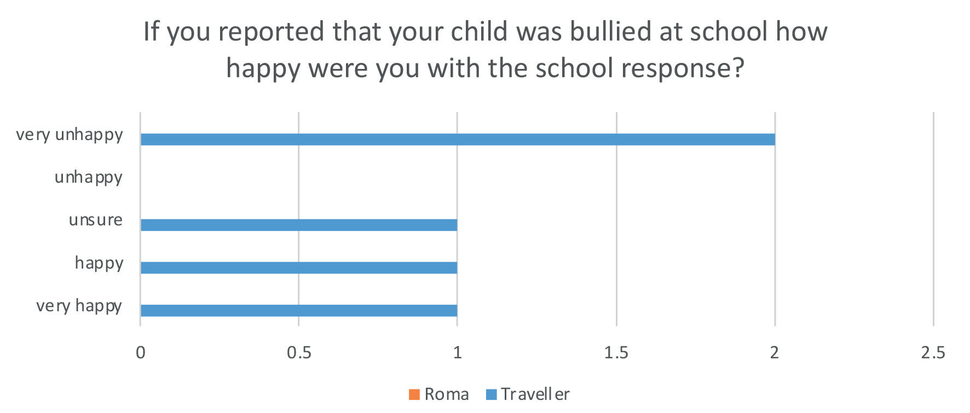
Figure 4.3: Parents’ happiness with the school response to reports that their child was bullied (n=5)
Similarly, one Traveller parent felt that the school was very unhelpful at putting a stop to the bullying. One Traveller parent reported that the school was very helpful. However, this parent had never indicated that their child was bullied. Another two Traveller parents described the school response as helpful yet one of these parents indicated earlier that their child had not been bullied at school. Again perhaps the comments from the parents of the children who had not been bullied reflect their perception of the school’s approach to bullying in general.

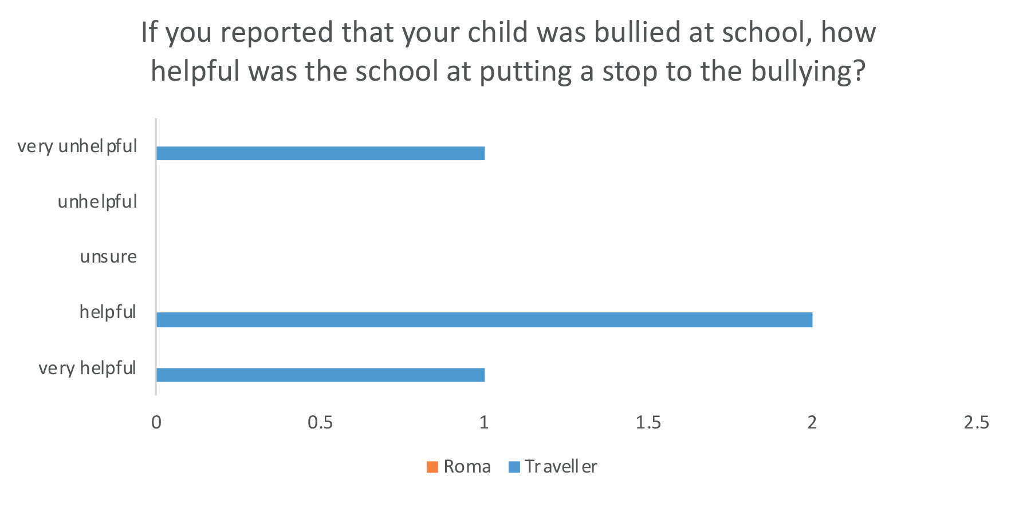
Figure 4.4: Parents’ perceptions regarding how helpful the school was at putting a stop to the bullying (following a bullying report) (n=4)

Communication with school

When asked whether any member of school staff contacted them about their child being bullied in the previous year, three Roma parents (of children who had been bullied once or twice) were contacted by the school once. Similarly, the parent of a post-primary school Traveller pupil (who was frequently bullied) was also contacted by the school once.

Parent’s perspective of how bullying affected their child’s participation in school?

Only one parent (of a child who was bullied) responded to the question of how bullying impacted their child’s participation at school. The grandparent of the girl who was blamed for being bullied said

“She left school over it because it was so bad she didn’t want to go. She is going back to the same school now but she has no other choice in the matter otherwise her parents will be punished. A lot of children have moved to other schools because of the principal in the girl’s school.”

Parent’s reports of school strategies to support parents to recognise a deal with bullying

Parents were asked what the school does to support parents to recognise and deal with bullying, Parents were provided with a list of options and could tick all that applied. Parents also had the option of inserting an additional response. Almost two thirds (64.5%) of parents did not know what schools do to support parents to recognise and deal with bullying. This was particularly apparent among Roma parents (even Roma parents of children who were bullied) with 96.6% affirming that they were unaware how schools help parents with this problem. There were also comments from two Traveller parents saying

“There is a policy but it is not addressed. The school says there is no problem but there is”

“The school does nothing”

The most commonly reported strategy related to accessing the school’s anti-bullying policy. Some indicated that they were given a copy of the anti-bullying policy (22.6%), knew that it could be accessed on the school website (17.7%) or via the parent’s association (12.9%). The next most
frequently mentioned support pertained to being told about warning signs that might suggest that their child is being bullied with 12.9% of parents identifying this as an action to help them recognise and deal with bullying.

While a proportion of parents knew how to access the anti-bullying policy, there was less evidence that parents were familiar with the content of same. Only 11.3% of parents indicated that the policy gives examples of types of bullying behaviour. A mere 8.1% of parents reported that they were aware of the teacher with responsibility for dealing with concerns and just 12.9% of parents affirmed that the policy outlines how the school deals with bullying concerns. Lastly, few (4.8%) were aware of what parents
can do if they are not satisfied that the school has adequately dealt with their concern about their child being bullied.

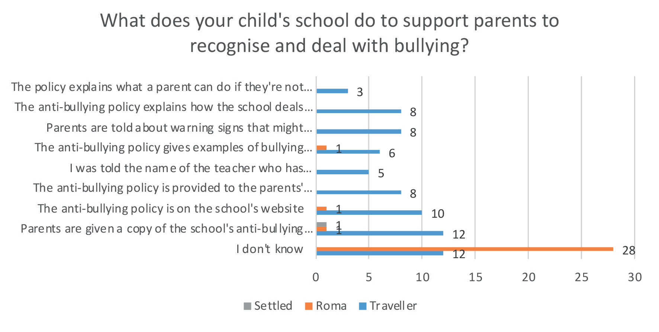
Figure 4.5: Parents’ reports of school actions to support parents to recognise and deal with bullying (n=58)

5. Anti-bullying co-ordinators’/teachers perspectives on actions to prevent and counteract bullying towards Traveller and Roma pupils

Anti-bullying co-ordinator/Teacher survey

According to the Anti-Bullying Procedures for Primary and Post-Primary schools (Department of Education and Skills, 2013), school based bullying can be positively and firmly addressed through a range of school based measures. Therefore, in order to gain insight into the experiences of Traveller and Roma pupils, it was critical to seek the perspective of teachers regarding actions to prevent and counteract ethnicity based bullying.

The teacher survey was designed to be taken by anti-bullying co-ordinators and initially distributed online to all school principals in primary and post-primary schools in the Republic of Ireland in December 2019 with a further reminder sent in January 2020 before the survey closed in February 2020. Participants were advised that the survey was intended for the anti-bullying coordinator in schools with either Traveller and/or Roma pupils enrolled. One hundred and twenty- three responses were received: 73 from primary schools; 47 from post-primary schools; and 3 did not indicate the type of school in which they were working.

The teacher survey was mainly quantitative in nature, containing 30 questions specifically related to objectives developed in consultation with Traveller and Roma organisations represented on the Education sub-group of the NTRIS steering group. However, six out of the thirty questions allowed for a more qualitative response. Teachers were asked about the number and proportion of Traveller and Roma pupils enrolled at their school; whether their school’s anti-bullying policy referred specifically to
bullying of pupils relating to their membership of the Traveller and Roma communities; whether they recorded incidents of identity based bullying towards Traveller and Roma; and had evidence relating to the prevalence of same; what actions they take to counteract and prevent ethnicity based bullying; and how the anti-bullying policy is communicated to the school community.

Those in the role of anti-bullying co-ordinator included: principals (n=97), deputy principals (n=7), assistant principals (n=4), teachers (n=9), guidance counsellors (n=2), Special Needs Assistant (n=1),
Traveller mentor (n=1), and an administrator (n=1). One participant skipped the question.

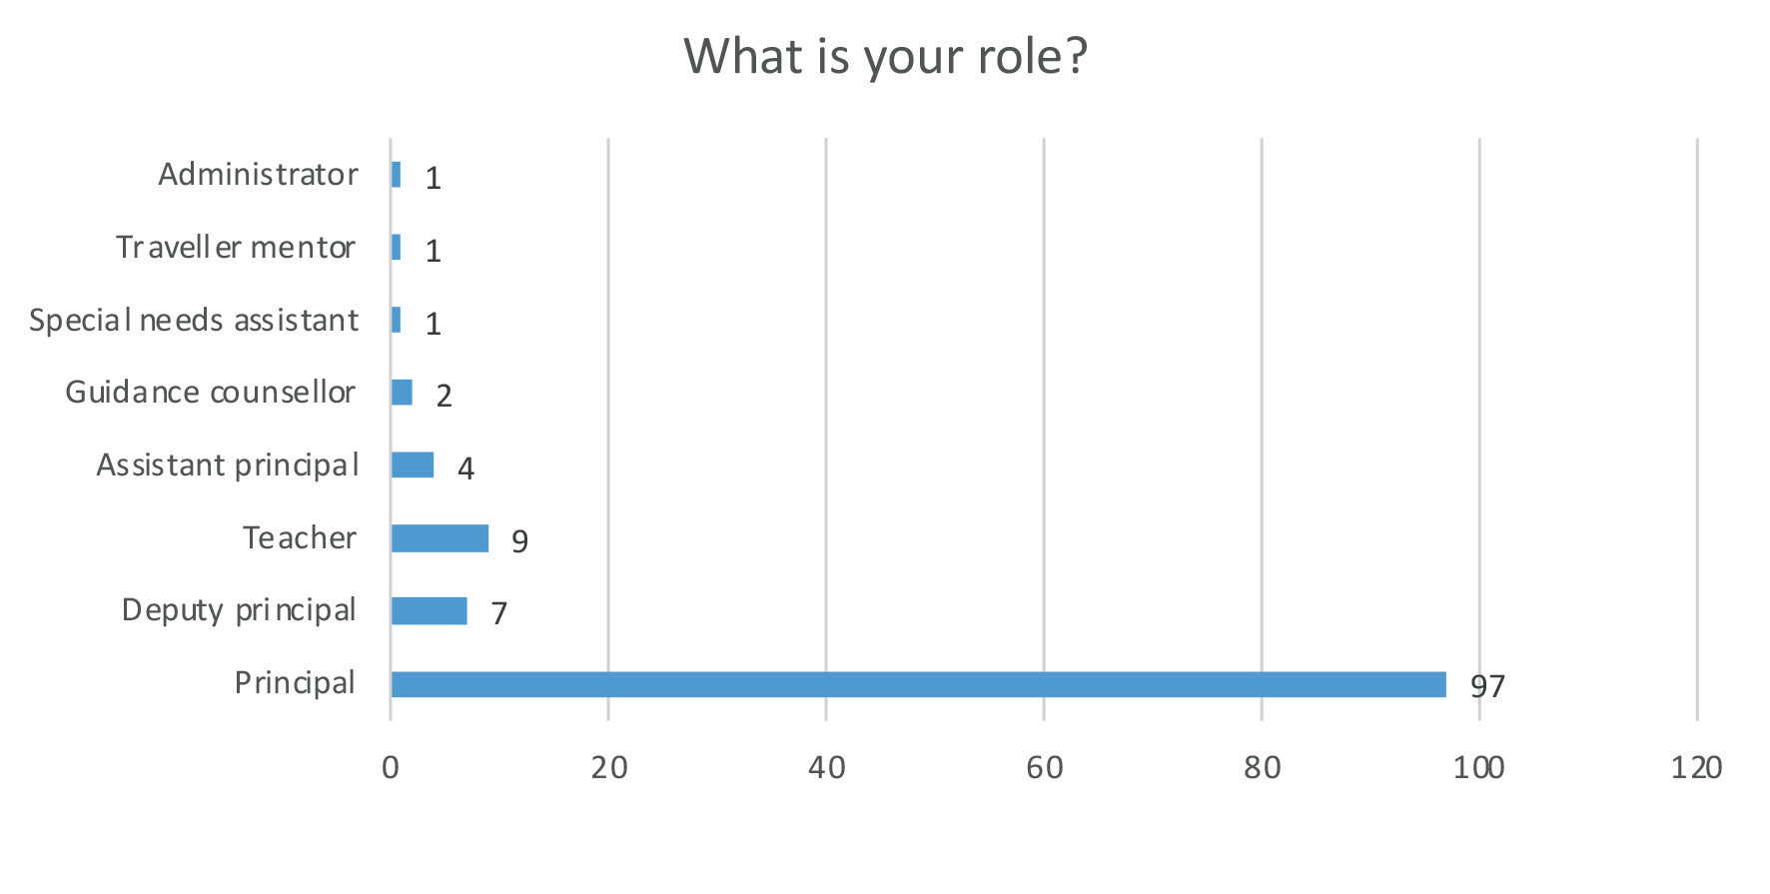
Figure 5.1: Primary role of participants occupying the role of anti-bullying co-ordinator (n=122)

With respect to ethnicity, most respondents described themselves as Irish (n=66) or White Irish (n=39). A variety of descriptors were used by participants to describe their ethnicity including: African (n=1),
Catholic (n=1), Irish Catholic (n=1), Caucasian (n=2) and White, Non-Irish (n=1). Twelve respondents skipped this question. However, the results suggest that the anti-bullying co-ordinators who responded to the survey comprise an ethnically homogenous group. The responses also suggest that some confusion exists around the term ethnicity.

Number and proportions of Traveller and Roma pupils in surveyed schools

Eighty-four percent (n=101) indicated that there were Travellers enrolled at their school. Reported numbers of Traveller pupils ranged from 0 to 160 with 2 and 5 pupils being the most frequently cited number (n=9 respectively). Thirty-six per cent (n=43) stated that there were Roma pupils enrolled at their school and 8.4% (n=10) didn’t know whether any Roma were enrolled. Reported numbers ranged from 0 to 40 with 2 Roma pupils being the most frequently cited number (n=7).

Respondents were also asked to estimate the proportion of the pupil population that are members of the Traveller community. The results suggest that, among surveyed schools, Traveller and Roma pupils account for a small proportion of the pupil population.
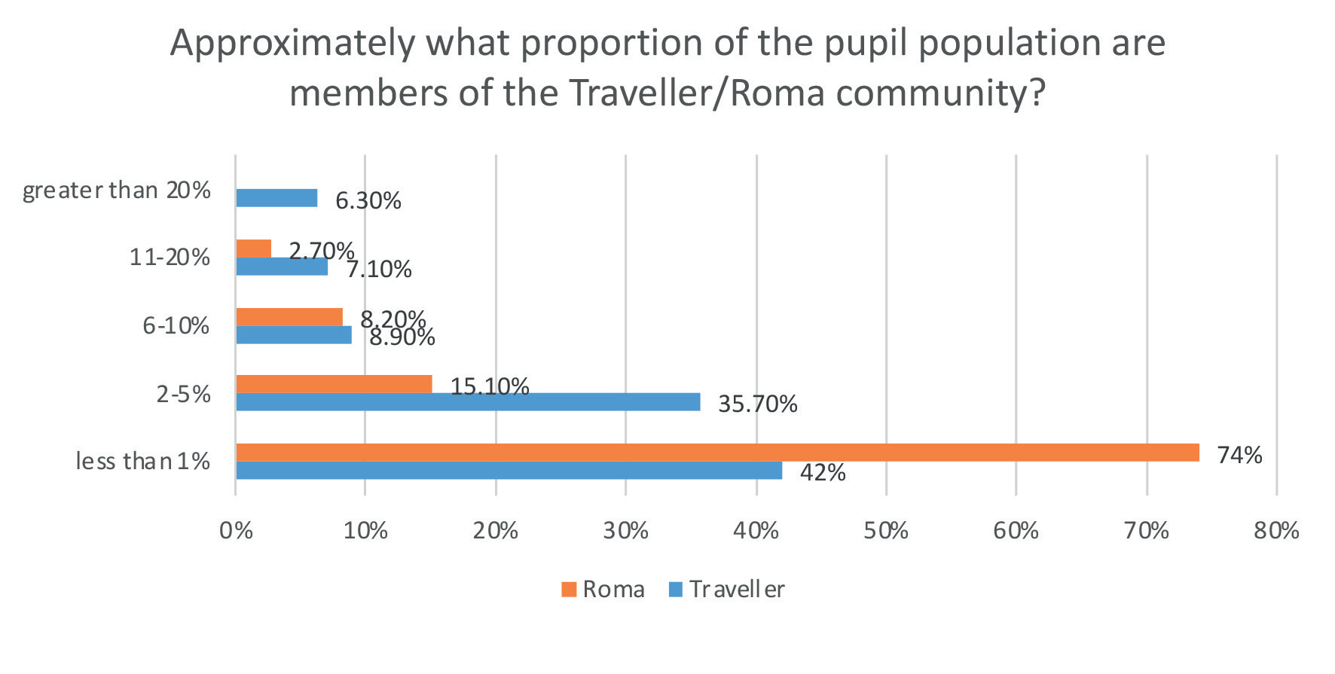
Figure 5.2: Approximate proportion of pupil population that are members of the Traveller/Roma community (n=112 re Travellers, n=73 re Roma)

Naming Traveller and Roma groups in anti-bullying policies

Participants were asked whether their school’s anti-bullying policy referred specifically to bullying of children and young people relating to their membership of the Traveller community. Just over half (52%, n=53) affirmed that they did, 45.1 % (n=46) indicated no, and 2.9% (n=3) replied that they did not know. Similarly, with respect to the Roma community, only 10% (n=10) of respondents indicated that their anti-bullying policy referred specifically to bullying of children and young people relating to their membership of the Roma community, whereas 85% (n=85) said that it did not make specific reference to Roma pupils. Five percent (n=5) of participants indicated that they did not know.

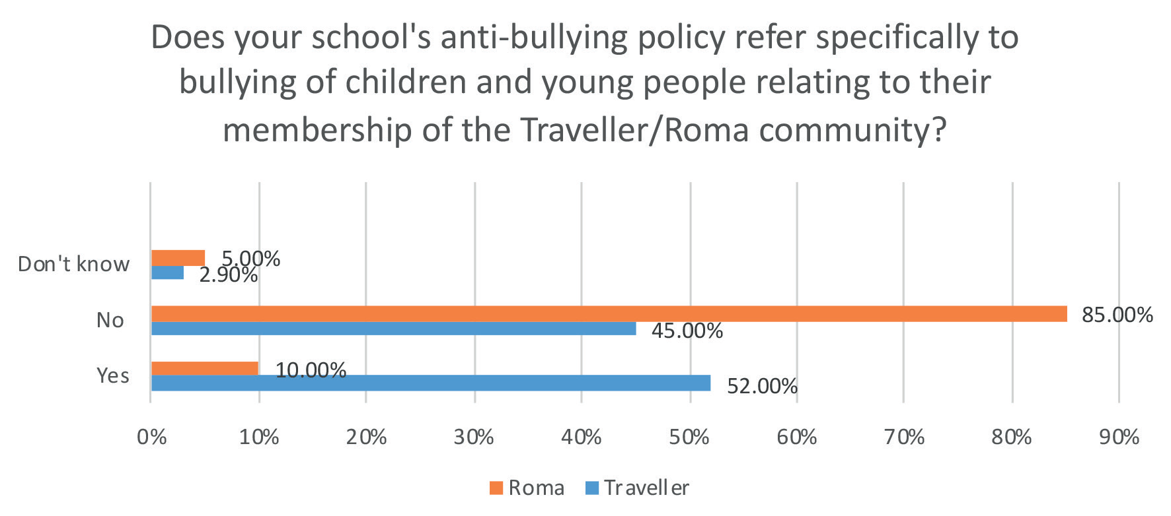
Figure 5.3: Participant’s reports regarding whether or not their school’s anti-bullying policy refers specifically to bullying of children and young people relating to their membership of the Traveller/Roma community (n=102 re Travellers and n=100 re Roma)

With regard to recording incidents of identity based bullying specifically related to Travellers, 51.5% (n=50) of participants said they did record such incidents, 44.3% (n=43) indicated that they did not, and 4.1% (n=4) did not know. With respect to Roma, 35.9% (n=33) participants said they recorded incidents of identity based bullying towards Roma, with 53.3% (n=49) indicating that they did not, and
10.9% (n=10) did not know.

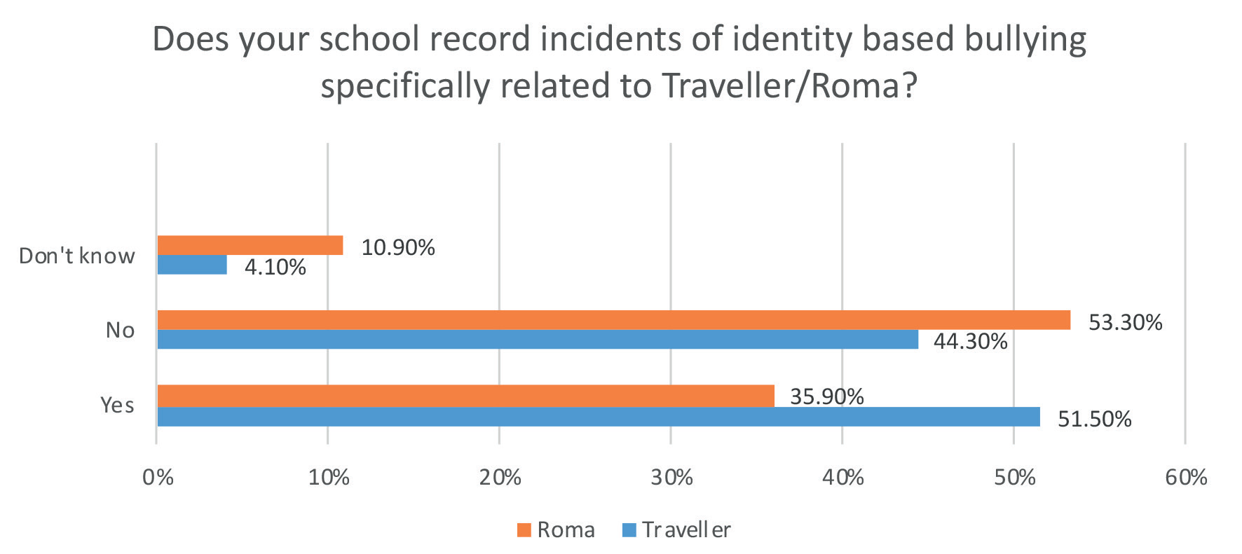
Figure 5.4: Participants’ reports regarding whether or not their school records incidents of identity based bullying specifically related to Traveller/Roma group membership (n=97 re Travellers, n= 92 re Roma)

When asked whether the school reported incidents of the above types of identity based bullying to the parents of the alleged victims of bullying, most respondents said that they did (83.7%, n=82), 13.3% (n=13) said that they did not and 3.1% (n= 3) replied that they did not know.

Prevalence of identity based bullying towards Traveller and Roma pupils

When asked whether the school has any evidence related to the prevalence of identity based bullying towards Traveller pupils, 27.6% (n=27) said yes, 69.4% (n=68) replied no, and 3.1% (n=3) did not know.
When asked whether the school has any evidence related to the prevalence of identity based bullying towards Roma pupils, 14.1% (n=13) said yes, 78.3% (n=72) replied no, and 7.6% (n=7) did not know.

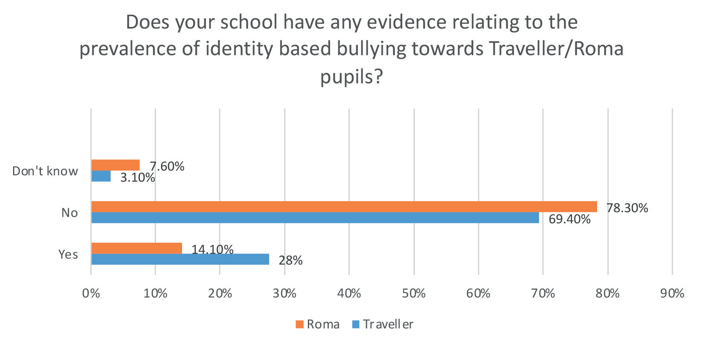
Figure 5.5: Participants’ reports regarding whether their school has any evidence related to the prevalence of identity based bullying towards Traveller/Roma pupils (n= 98 re Travellers, n=92 re Roma)

Participants were asked to state (if available) the number of incidents of identity based bullying towards Traveller and Roma pupils in the last 12 months. Responses ranged from zero incidents (n=103) to three incidents (n=2). Of those that elaborated on the type of bullying, one described verbal bullying (towards a Traveller) by a behaviourally challenged pupil with an Autistic Spectrum Disorder that was dealt with promptly. Another co-ordinator said that there was one incident of bullying towards a Roma pupil but it was not based on their ethnicity.

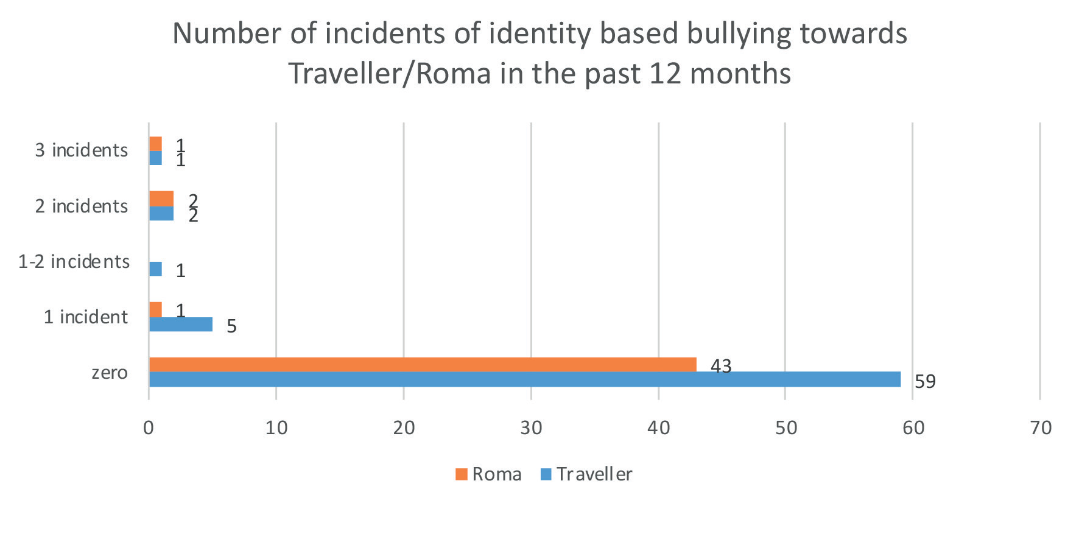
Figure 5.6: Participants’ reports regarding the number of incidents of identity based bullying towards Traveller/Roma in the 12 months prior to the study (n=69 re Travellers, n=47 re Roma)

Actions to counteract identity based bullying

Participants were asked about actions taken to counteract bullying if an incident of identity based bullying is reported. Only 35.7% (n=44) of anti-bullying coordinators offered their perspective with 48.7% declaring that no incidents of identity based bullying have been reported.

Among the co-ordinators (that answered the question) 97.7% say that they talk to the alleged victim and write down their account of what happened, who bullied them, where, when and why. All of the respondents talk to the alleged bully and 90.9% write down the bully’s account of what happened. 88.6% said parents of the alleged victims and bullies are contacted. Only 36% affirmed that they report the bullying to the principal. 88.6% follow up with the alleged victim to ask whether the bullying has stopped with one emphasising the importance of careful monitoring and that they follow up daily. Another emphasised the need to follow up with victim and parents and 52% say the bully is punished.

Twenty-eight participants provided additional comments, either describing extra actions to counteract identity based bullying or elaborating further on strategies used. Two respondents indicated that the approach to addressing bullying is the same regardless of whether or not it is identity based, with one stating that All bullying is dealt with in same manner. The other maintained that they would follow procedures and document all bullying in the same way. Race/ ethnicity does not change this if they are
being bullied or bullying.

Restorative practice

There were 14 references to using restorative practice which entails getting the pupil who engages in bullying behaviour to reflect upon his/her unacceptable behaviour, experience a sense of remorse, and act to restore a damaged relationship with both the pupil who is bullied and the class and/or school community.

The school code of behaviour/discipline

There were references to the school code of behaviour/discipline to deal with established cases of bullying, particularly when restorative practice is not appropriate or has not been effective in resolving the problem. One co-ordinator suggested that the type of bullying influenced the response declaring that “if racial probably a sanction. “

Recording and reporting

Two participants described how incidents of bullying are reported at each Board of Management meeting.

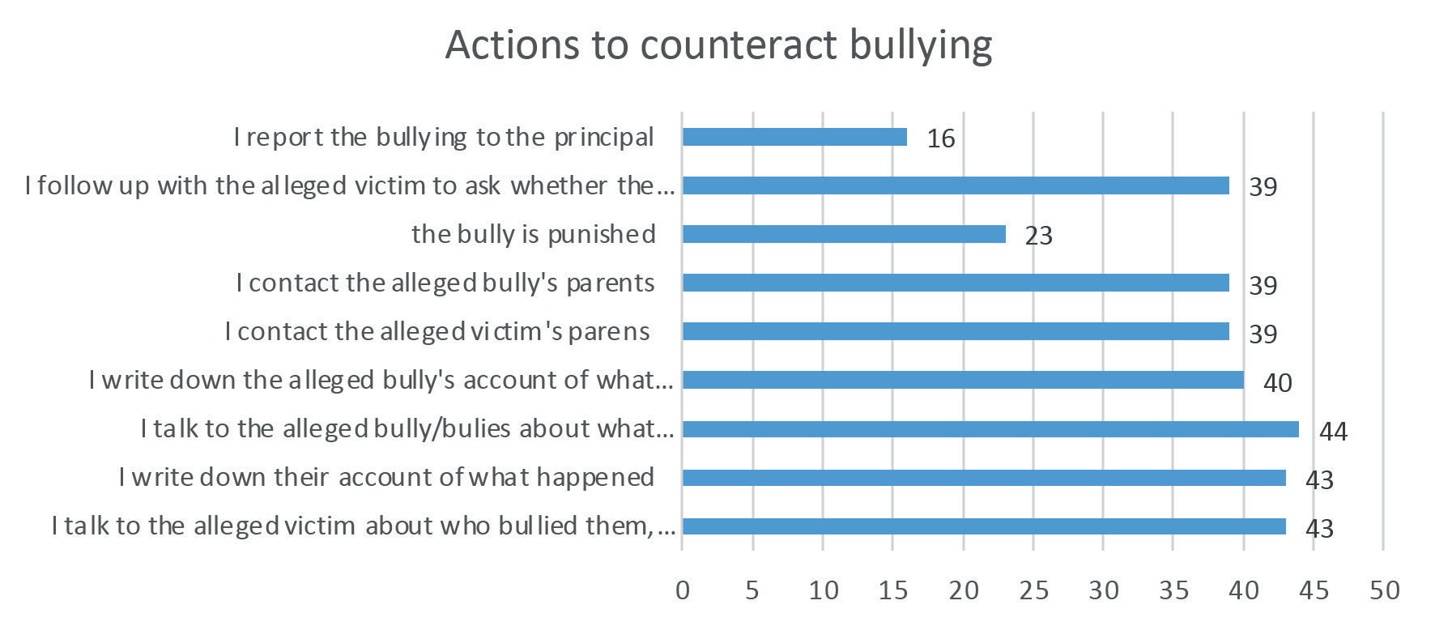
Figure 5.7: Participants’ reports regarding actions to counteract bullying (n=44)

Communicating the school’s anti-bullying policy to the school community

Anti-bullying co-ordinators were given a list of strategies to communicate the school’s anti-bullying policy to the school community and could tick all strategies that applied. They also had the option of inserting additional responses. The most commonly reported approaches to communicating the anti-bullying policy to parents was by publishing it on the school website (77.2%), making it available to the parents’ association (69.1%) and providing parents of incoming pupils with a copy of the policy (59.3%). However, only 7.3% provided copies in the parent’s native language. Most anti-bullying coordinators affirmed that the anti-bullying policy explains how the school deals with bullying concerns (74.8%) and that the policy gives examples of bullying behaviour (62.6%). However, less than half (48%) reported that parents are informed of possible warning signs that that their child is being bullied and just over a third (36.6%) included (in their policy) examples of identity based bullying behaviour. One school mentioned that every year they provide parents with a leaflet regarding bullying with the school newsletter.

Curriculum programmes were most popularly used to enhance pupils’ ability to recognise and cope with bullying (74%), and to promote respect for diversity and inclusiveness (69.1%). The majority of schools also asserted that students are informed of the relevant teachers responsible for dealing with bullying concerns (61.8%) and that information on bullying is provided in pupil-friendly, age appropriate formats and displayed around the school building (57.7%). Some also included a bullying awareness day for pupils (39.8%). There were comments from two co-ordinators about including advice on how to avoid bullying and procedures to report it in each child’s journal; and that a dedicated email address is widely circulated amongst students (and parents) to report any concerning behaviours.

There were comments from 17 respondents elaborating further on the theme of communicating the anti-bullying policy to students. There were references to specific programmes (curricular and/or extracurricular) that were used in order to promote awareness of bullying and how to deal with it along with initiatives related to: friendship; inclusion; empathy; well-being; and positive representation of Traveller and Roma culture.

Most schools recognised the importance of a whole school community approach to tackling bullying. Thus, 66.7% indicated that non-teaching staff (e.g caretakers, cleaners, secretaries, SNAs) are encouraged to report any incidents of bullying witnessed by them or mentioned to them to the relevant teacher. Similarly, a majority of schools confirmed that temporary and substitute staff are made aware of the school’s code of behaviour and the school’s anti-bullying policy (71.5%).

The least common approach to communicating the school’s anti-bullying policy was bullying awareness days for staff (15.4%) and parents (13%).

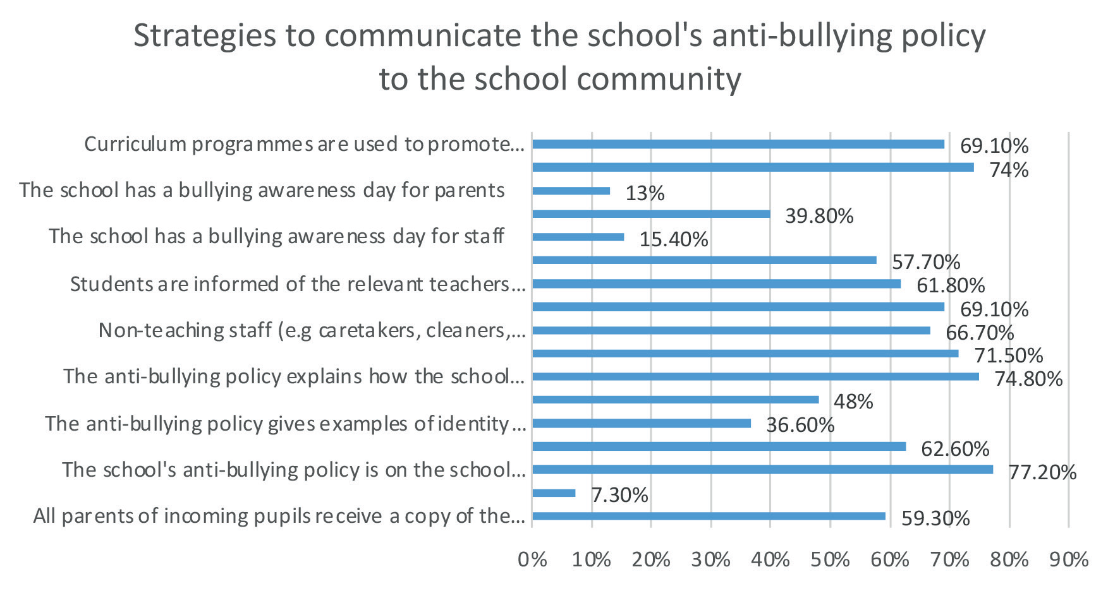
Figure 5.8: Participants’ reports regarding strategies to communicate the school’s anti-bullying policy to the school community (n=95)

One co-ordinator explicitly stated that students, parents, and staff are consulted in the course of the review of the anti-bullying policy and another highlighted the staff policy regarding dignity in the workplace.

Strategies to prevent identity based bullying towards Travellers and Roma pupils

Just over a fifth (21.1%) of anti-bullying co-ordinators indicated that they use specific strategies to prevent identity based bullying towards Travellers and/or Roma. Some explained that identity based bullying was prevented by strategies to prevent bullying in general such as the anti-bullying charter and the anti-bullying policy.

Promote awareness of and respect for Traveller/Roma culture

There were references to promoting awareness of Traveller culture through initiatives such as: Traveller pride events and Traveller celebration weeks. Similarly, the Yellow Flag programme, guest speakers, and in class discussions of Traveller/Roma identity (in the context of a wider focus on inclusion and diversity) were used to promote awareness of both Traveller and Roma culture and identity. The aim of these efforts appeared to be about raising awareness of Traveller/Roma traditions and fostering respect for them. One co-ordinator described the Traveller pride events as “very powerful in enhancing the self-esteem of our Traveller pupils and have created an awareness amongst other pupils of the values of Traveller culture.”

Programmes and initiatives to promote a more caring and fair society

There were references to the Young Social Innovators programme and Human Rights month as strategies to prevent identity-based bullying towards Traveller and Roma. The goal of the former programme is to enable students to bring about positive social change for the benefit of people, communities and the environment. Similarly, Human Rights Month invites students to reflect on the ways that they have treated others and purports to empower participants to stand up for their rights and the rights of others.

Promote kind and respectful relationships across the school community

Similarly, there were several references to promoting respect and/or kindness. Co-ordinators talked about daily or constant reminders of the importance of kindness to others with one school asserting that they operate a “zero tolerance policy” on all acts of unkind behaviour to others.

Lastly, one participant outlined how senior management engages with the Gardaí regularly regarding problems in the community.

6. Summary and Conclusion

Among the small sample (n=71) of Traveller and Roma pupils surveyed, most reported that they liked school (71%) and had a few good friends at school. In response to a direct question, fifteen per cent (n=11) reported that they had been bullied in the past year with name calling, racist name
calling, exclusion, and bullying by teachers being cited as the most frequent types of bullying that they experienced. Responses received from two other pupils in respect of subsequent questions also indicated that they experienced bullying. Typically, the bullying was perpetrated by peers in their grade or teachers. Bullying by peers tended to happen in areas of unstructured supervision such as the playground. However, bullying by teachers took place in the classroom and Traveller pupils described teacher behaviour that was demeaning and made them feel unwanted and excluded.

Although some pupils reported bullying to teachers (and were happy with the teacher’s response) there was understandable reluctance on the part of Traveller pupils who were being bullied by teachers to do the same. Moreover, there was evidence in one case that reports of bullying were not always investigated and this had implications for one Traveller pupil’s confidence in telling.

There was ample evidence of discrimination such as: being left out by peers and teachers; being called names; and teachers having low expectations of them. These forms of discrimination were particularly apparent among Traveller pupils.

Pupil participants revealed the severe and negative impact of their experience of bullying on their: emotional well-being; ability to concentrate; sense of inclusion and belonging; and overall mental health. There was also evidence that being bullied influenced participants’ attendance and their decision to leave school. In two instances pupils were suspended with one explaining that they “eventually fought back.”

In general parents reported that their child liked school and the majority of parents surveyed indicated that their child had not been bullied in the past year. Among the 11% (n=7) of parents who affirmed
that their child had been bullied in the past year, some reported the bullying to school staff and were happy with the school’s response. However, there was some evidence of reluctance to report bullying. This was due to: fears that their child would be blamed; the bullying would get worse; the lack of proof/ evidence that their child was being bullied; and the belief that the school would not do anything to stop the bullying and that their child would be suspended.

A range of procedures to investigate and address bullying was described by pupils, parents and anti-bullying co-ordinators. Typically, actions included: talking to all those involved, writing down their respective accounts of what happened and contacting their parents. Teachers also made several references to the use of restorative practice to resolve conflict. While most of the teachers asserted that they follow up with the victim to ask whether the bullying has stopped, only one pupil acknowledged that this had happened. Similarly, of the 3 parents who reported bullying, none of the parents indicated that anyone followed up with either themselves, their child or the bully to ask whether the bullying had stopped.

Pupils, parents and teachers outlined a number of approaches that were designed to enhance members of the school community’s ability to recognise and cope with bullying and promote inclusion and respect
for diversity. Most teachers identified curriculum programmes as a key strategy to enhance pupils’ ability to recognise and cope with bullying. Providing access to the school’s anti-bullying policy was cited
as the most common strategy to support parents to recognise and deal with bullying. However, almost all Roma parents were unaware of how schools help parents with the problem of bullying. In addition, subsequent comments from Traveller and Roma parents revealed that very few were familiar with the content of the policy. Thus, few understood how the school deals with bullying concerns.

For pupils the most frequently reported strategies to raise their awareness of bullying entailed displaying information about bullying around the school building and including the school rules in notebooks and journals. More than half of the pupils also acknowledged that they were encouraged to respect people who are different to them and they were taught what to do if someone they know is being bullied.

With regard to anti-bullying policies making specific reference to the bullying of children related to their membership of the Traveller community and the Roma community, only 52% of schools referenced Travellers and 10% named Roma. Similarly, just over half recorded incidents of identity based bullying specifically related to Travellers, and only 35.9% recorded incidents of identity based bullying towards Roma. While, just over a quarter of schools had evidence related to the prevalence of identity based bullying towards Traveller pupils, only 14.1% indicated that similar records were kept with respect to Roma students. Analysis of anti-bullying co-ordinators’ responses suggests that there had been approximately 21 incidents of ethnicity based bullying towards Traveller/Roma in the year
prior to the survey.

Reported actions to counteract and prevent identity based bullying were similar to those to address and tackle bullying in general and included: investigating allegations of bullying; recording and reporting; restorative practice; and recourse to the school code of behaviour. Additional efforts to prevent ethnicity based bullying entailed: promoting awareness of and respect for Traveller/Roma culture; including programmes and initiatives to create a more caring, equal and fair society; and promoting kind and respectful relationships across the school community.

7. Implications, limitations and recommendations

Overall the findings imply evidence of good practice with respect to bullying prevention because most Traveller and Roma participants liked school, had a few good friends, and had not been bullied in the
previous year. There were also some positive reports from pupils and parents of successful efforts to investigate and address bullying towards Traveller and Roma pupils. In addition, Traveller and Roma students were quite confident that teachers often tried to put a stop to bullying and the majority of anti-bullying co-ordinators described using curricular programmes to enhance pupils’ ability to recognise and cope with bullying.

However, the findings should be interpreted with caution. Firstly, the use of convenience sampling, along with the small pupil sample, means it is not possible to calculate an accurate prevalence rate of bullying. Furthermore, teacher reports of prevalence are likely to be conservative given that recording incidents of bullying towards Traveller and Roma was not common practice in surveyed schools.

Secondly, it is not possible to generalise the findings (both positive and negative) to the wider population of Traveller and Roma pupils. Many of the pupils were from the same extended family and attended the same school and therefore only a small number of schools are represented in the sample.

It is also important to bear in mind that several factors influence reported rates of bullying and there are multiple reasons why young people might not disclose bullying. According to DeLara (2012) some reasons include: having differing definitions of bullying to adults; accepting bullying and harassment as the norm; adults taking no action or ineffective action against bullying; being shamed by an authority figure; fear of parental intrusion; fear of not being taken seriously; and the shame of victimhood and giving the appearance of weakness.

However, the perspectives of surveyed parents and pupils (particularly those who were bullied) provide valuable information regarding aspects of the anti-bullying procedures that could be improved to ameliorate Traveller and Roma pupils’ experience at school.

Integrate anti-racism training across teacher continuing professional development programmes

In light of the racist name calling and exclusion experienced by Traveller and Roma pupils, themes of anti-racism and intercultural awareness should be prioritised and integrated across continuing professional development programmes for primary and post-primary teachers.

Similarly, teachers need to be equipped to address the teaching and learning needs of all students from all cultural backgrounds and use pedagogical practices that promote inclusion. This is particularly
important because pupil participants complained that teachers had low expectations of them, a phenomenon also reported by other minoritised groups where teachers even allocate blame for underachievement to the children themselves (Mampaey and Zanoni 2016; Sprecher 2013; Vaught
and Castagno 2008). Research suggests that the first step in challenging low expectations is to create opportunities for teachers to interrogate their own settled, middle-class White privilege, the prejudices they hold about minoritized groups and the dominant discourses that shape their views.

Create a positive school culture and climate

Pupils’ reports of racist name calling and exclusion also highlight the need for much greater attention to cultivating a positive school culture and climate. The principal is in a key role to influence attitudes and therefore should set inclusive and respectful standards and take steps to prevent and address harassment on the nine grounds. Furthermore, since pupils model their behaviour on adults, all school staff should be careful to act as good role models.

Create Use curricular programmes to promote respect, belonging and inclusion

Racist name calling and exclusion should also be addressed through curricular programmes that: foster an attitude of respect; promote belonging and inclusion; address prejudice and stereotyping; provide opportunities to develop a positive sense of self-worth; and highlight the unacceptability of bullying behaviour.

Raise awareness of what to do about concerns of teacher bullying

All members of the school community should be informed of the procedure for investigating and reporting teacher bullying. This should be clearly outlined in the school’s anti-bullying policy along with options for parents in the event that they are unhappy with the outcome of a school investigation.

Remove barriers to reporting bullying

Both pupils and parents expressed some reluctance to report bullying. Therefore, schools should provide opportunities for pupils and parents to raise concerns in a comfortable and non-threatening environment. Pupils should be supported and encouraged to disclose bullying behaviour (including teacher bullying) and reporting incidents should be considered responsible behaviour. Providing a bullying awareness day for parents might also give them the confidence to approach the school should they have concerns about their child being bullied.

Adopt a consistent approach to dealing with bullying

All reports of bullying should be investigated and dealt with so that pupils will gain confidence in telling.

Follow up, record and report

Reports of bullying behaviour need to be followed up with relevant parties. Follow up meetings should be arranged within 20 school days after the relevant teacher has determined that bullying has occurred. In so doing the teacher will be in a position to determine whether or not the bullying has been adequately and appropriately addressed. In circumstances where the bullying has not ceased, the teacher must use the recording template in Appendix 3 of the Anti-Bullying procedures and provide a copy to the principal or deputy principal as applicable. These procedures will support the evaluation of the effectiveness of the school’s anti-bullying policy. Data gathered from bullying reports can be analysed to monitor levels of bullying behaviour and identify trends that warrant further intervention.

Provide comprehensive supervision and monitoring

Schools should provide comprehensive supervision and monitoring through which all aspects of school activity are kept under observation, for example in the school yard and when pupils are moving between classes. This will help minimise opportunities for bullying. This is particularly important because continuing provocation could lead to a physical fight and ironically in some cases the person being bullied may appear to be the aggressor.

Raise parents’ awareness of bullying

It is essential that all members of the school community have a clear understanding of the anti-bullying policy aims and content if the policy is to form the basis for developing effective strategies for dealing
with the problem. Therefore, parents need to be supported to become familiar with the content of the anti-bullying policy. This could be facilitated through means such as: bullying awareness days; the provision of summary leaflets; and translating key documents for minority language speakers such as Roma parents.

Name bullying of Travellers and Roma in the anti-bullying policy

Schools should make specific reference (in their anti-bullying policy) to bullying based on a person’s membership of the Traveller/Roma community. It would also be helpful to provide an explanation of the terms ethnic and racial groups. This would heighten school community members’ awareness of what constitutes ethnicity-based and racial bullying and therefore they would be in a better position to recognise and address it.

Provide support for pupils affected by bullying

Lastly, given the devastating impact of bullying on those affected, a programme of support should be made available to pupils. Such pupils may need counselling and/or opportunities to participate in activities designed to raise their self-esteem. This is also relevant to pupils who witness ethnicity based bullying, and share that ethnicity, as they can experience anxiety and feel under threat themselves. They may also feel guilt or distress at not being able to help the person being bullied.

Finally, the proposed recommendations must be seen as just one component of a more comprehensive strategic approach which is needed so that access, participation and outcomes for Travellers and Roma in education are equal to those for the majority population.

References

deLara, E.W. (2012). Why adolescents don’t disclose incidents of bullying and harassment. Journal of School Violence, 11(4), 288-305. https://doi.org/10.1080/15388220.2012.705931

Department of Education and Skills (2013). Anti-Bullying Procedures for Primary and Post-Primary Schools. Government of Ireland.

Mampaey, J. & Zanoni, P. (2016). Reproducing monocultural education: Ethnic majority staff’s discursive constructions of monocultural school practices. British Journal of Sociology of Education, 37 (7), 928–946. https://doi.org/10.1080/01425692.2014.1001059

Olweus, D. (2006). Revised Olweus Bully/Victim Questionnaire (OBVQ). APA PsycTests.

Sprecher, K. (2013). Preparing teacher-researchers for local-global, multicultural classroom: Prospects for postcritical and feminist qualitative methodologies. Taboo: The Journal of Culture in Education, 13 (2), 27–50.

Vaught, S. E., & Castagno, A.E. (2008). I don’t think I’m a racist”: Critical race theory, teacherattitudes, and structural racism. Race Ethnicity and Education, 11(2),95-113. https://doi.org/10.1080/13613320802110217

Wong, C.A., Eccles, J.S. & Sameroff, A. (2003) The influence of ethnic discrimination and ethnic identification on African American adolescents’ school and socioemotional adjustment. Journal of Personality, 71(6), 1197-1232

